Quantitative strategies on High Frequency Data

Final report

Sujith Madesh and Kacper Mosoń

Jan 24, 2026

# Group 1

## Approaches undertaken

We tested three intraday, rule‑based strategies on high‑frequency futures data for **Group 1 (NQ, SP)**. For each strategy we evaluate performance **quarter by quarter**, report gross vs net metrics (with transaction costs), and select a final parameter set using an explicit **in‑sample** period to avoid look‑ahead.

### Common assumptions (applied to all strategies)

* **No look‑ahead:** signals are translated into positions with a one‑bar delay (we only trade using information available at t−1).
* **Trading window constraints / filtering:** we use a no\_trade flag (built during data preparation) to force positions flat around the open/close and other excluded minutes. When no\_trade==1, position is set to 0.
* **Transaction costs:** each position change incurs a fixed per‑contract cost; we report both **gross** and **net** PnL/Sharpe/Calmar.
* **Aggregation:** minute PnL is aggregated to daily PnL to compute Sharpe ratio and drawdowns more robustly.

### Group 1 (NQ, SP): strategies considered

**Strategy 1 — EMA crossover (trend following)**

* **Signal:** fast EMA vs slow EMA on price.
* **Entry/exit:** go long when fast EMA crosses above slow EMA; go short when fast crosses below slow (position flips on crossing).
* **Parameters searched (grid):**
  + fastEMA ∈ {15, 20, 30, 45, 60, 75}
  + slowEMA ∈ {90, 120, 150, 180, 240, 300, 360}
  + Constraint fastEMA < slowEMA
* **Variants:** we evaluate both **MOM** (trend-following) and **MR** (sign-flipped contrarian) using the same signal.

**Strategy 2 — Volatility Breakout (VB 2.2: EMA + volatility bands)**

* **Signal:** fast EMA signal $s_{t}$, slow EMA center $ℓ_{t}$, rolling volatility $σ_{t}$.
* **Entry/exit:** enter when $s_{t}$ breaks above $U_{t}=ℓ_{t}+mσ_{t}$ or below $L_{t}=ℓ_{t}−mσ_{t}$; hold until the opposite band is crossed or the flat constraint forces exit.
* **Variants:**
  + **MOM:** follow the breakout direction.
  + **MR:** take the opposite side (fade the breakout) when the regime is mean‑reverting.
* **Parameters searched (grid):**
  + signalEMA ∈ {10, 20, 45, 60, 75, 90}
  + slowEMA ∈ {90, 120, 150, 180, 240} with constraint signalEMA < slowEMA
  + volat\_sd ∈ {30, 60, 90} (rolling standard deviation window)
  + m ∈ {1, 2, 3} (band width multiplier)
* **Implementation detail (our helper function):** instead of ad‑hoc position rules, we generate positions using our reusable helper positionVB (see <functions/position_VB.py>). The function takes arrays for (signal, lower, upper, pos\_flat, strategy) and returns a stateful position series that:
  + enforces forced-flat periods via pos\_flat,
  + uses **t−1** values of the signal and bands to set the position at time t (prevents look-ahead),
  + supports both **MOM** and **MR** via a strategy flag.

**Strategy 3 — Risk‑filtered EMA / hybrid (RF‑EMA)**

* **Idea:** reduce crossover “churn” in sideways regimes by trading only when the EMA spread is large relative to recent volatility.
* **Additional indicator:**
  + rolling volatility vSD = rolling\_std(price, volat\_sd)
  + trend strength strength = |fast - slow| / vSD
* **Entry/exit:** follow the EMA crossover direction **only if** strength > z\_th (otherwise remain flat). We also evaluate MR by flipping the position sign.
* **Parameters searched (grid):**
  + fastEMA ∈ {15, 20, 30, 45}
  + slowEMA ∈ {90, 120, 180, 240} with constraint fastEMA < slowEMA
  + volat\_sd ∈ {30, 60, 90}
  + z\_th ∈ {0.5, 1.0, 1.5, 2.0}

### Parameter search and model selection (per group)

1. **Quarterly backtests:** for each quarter, contract, and parameter combination we compute minute PnL and aggregate to daily PnL. We report gross/net Sharpe, gross/net Calmar, cumulative PnL, and average daily transactions.
2. **Ranking statistic:** we compute an assignment statistic per quarter:
$$extstat=\left(\text{netSR}−0.5\right) max​\left(0, ln​\left(\left|\frac{\text{netPnL}}{1000}\right|\right)\right)$$

3. **In-sample selection (avoid leakage):**
   * We define INSAMPLE\_PERIODS as the set of valid quarter labels in the dataset (excluding invalid labels like None/nan).
   * For each contract and each strategy family, we aggregate results across the in-sample quarters and select the configuration that maximizes **sum(stat)**.
   * We require that the chosen parameter set appears in **all** in-sample quarters for that contract (consistency constraint).
   * To break ties, we apply a tiny turnover penalty: score = sum\_stat − 0.001 \* mean\_turnover.
   * We also select the best **side** (MOM vs MR) per contract.
4. **Final evaluation:** using the fixed parameters per contract, we report performance quarter-by-quarter for the full available set of quarters.

## Finally selected strategy for **group 1**

Provide a **general summary** (approach and a set of **final parameters**) for assets from **group 1**. (e.g. momentum strategy, cross over of two exponential moving averages EMA10 and EMA60).

**Selected strategy (Group 1): Volatility Breakout 2.2 (fixed parameters)**

We implement a volatility breakout rule based on an EMA signal and an EMA-centered volatility band:

* Compute a fast EMA signal $s_{t}$ and a slow EMA center $ℓ_{t}$.
* Compute rolling volatility $σ_{t}$ (rolling standard deviation).
* Define bands $U_{t}=ℓ_{t}+m σ_{t}$ and $L_{t}=ℓ_{t}−m σ_{t}$.
* Generate positions with our helper function positionVB (see <functions/position_VB.py>), which enforces forced-flat periods (pos\_flat) and uses **t−1** signal/band values to avoid look-ahead.
* Apply transaction costs per trade and report gross vs net results.

Final fixed parameters (chosen from the research notebook and kept constant across quarters):

* **NQ (Momentum / breakout):** signalEMA=20, slowEMA=60, volat\_sd=30, m=2.0
* **SP (Mean reversion):** signalEMA=90, slowEMA=180, volat\_sd=60, m=1.0

## Summary of results for **group 1**

| quarter | sym | gross\_SR | net\_SR | gross\_PnL | net\_PnL | gross\_CR | net\_CR | av\_daily\_ntrans | stat |
| --- | --- | --- | --- | --- | --- | --- | --- | --- | --- |
| 2023\_Q1 | NQ | 6.11 | 5.85 | 59253.00 | 56901.00 | 37.29 | 35.26 | 3.02 | 21.62 |
| 2023\_Q1 | SP | -0.98 | -1.34 | -6326.15 | -8606.15 | -1.68 | -2.15 | 2.92 | -3.96 |
| 2023\_Q3 | NQ | 0.83 | 0.52 | 6365.52 | 4013.52 | 1.92 | 1.15 | 3.02 | 0.03 |
| 2023\_Q3 | SP | 2.23 | 1.74 | 9282.50 | 7194.50 | 7.70 | 5.38 | 2.68 | 2.45 |
| 2023\_Q4 | NQ | 2.05 | 1.78 | 16052.96 | 13988.96 | 8.87 | 6.98 | 2.69 | 3.38 |
| 2023\_Q4 | SP | -0.08 | -0.50 | -340.20 | -2188.20 | -0.12 | -0.71 | 2.41 | -0.78 |
| 2024\_Q2 | NQ | -0.24 | -0.43 | -2615.56 | -4607.56 | -0.50 | -0.85 | 2.55 | -1.42 |
| 2024\_Q2 | SP | 3.07 | 2.70 | 15334.60 | 13366.60 | 9.56 | 7.99 | 2.52 | 5.70 |
| 2024\_Q4 | NQ | 2.87 | 2.65 | 26062.22 | 24166.22 | 20.90 | 19.00 | 2.43 | 6.86 |
| 2024\_Q4 | SP | 0.51 | 0.16 | 2757.60 | 861.60 | 0.97 | 0.27 | 2.43 | -0.00 |
| 2025\_Q1 | NQ | 0.54 | 0.33 | 5660.44 | 3404.44 | 0.98 | 0.57 | 2.98 | -0.21 |
| 2025\_Q1 | SP | 4.06 | 3.81 | 30609.65 | 28617.65 | 28.57 | 25.70 | 2.63 | 11.12 |
| 2025\_Q2 | NQ | 0.33 | 0.25 | 7438.44 | 5518.44 | 0.89 | 0.64 | 2.46 | -0.43 |
| 2025\_Q2 | SP | 3.87 | 3.71 | 42551.35 | 40607.35 | 25.84 | 24.20 | 2.49 | 11.87 |

**Commentary on the summary table (Group 1):**

The strategy is intentionally **diversified by style across assets**: NQ is traded with a momentum/breakout rule, while SP is traded with a mean‑reversion variant. This creates a regime-dependent profile: trending quarters tend to benefit NQ, while choppy/oscillating quarters tend to benefit SP. Across quarters, the difference between **gross** and **net** metrics highlights that **transaction costs and turnover are economically meaningful**; in lower-edge periods the cost drag can dominate.

## Equity line for **group 1** – 2023Q1

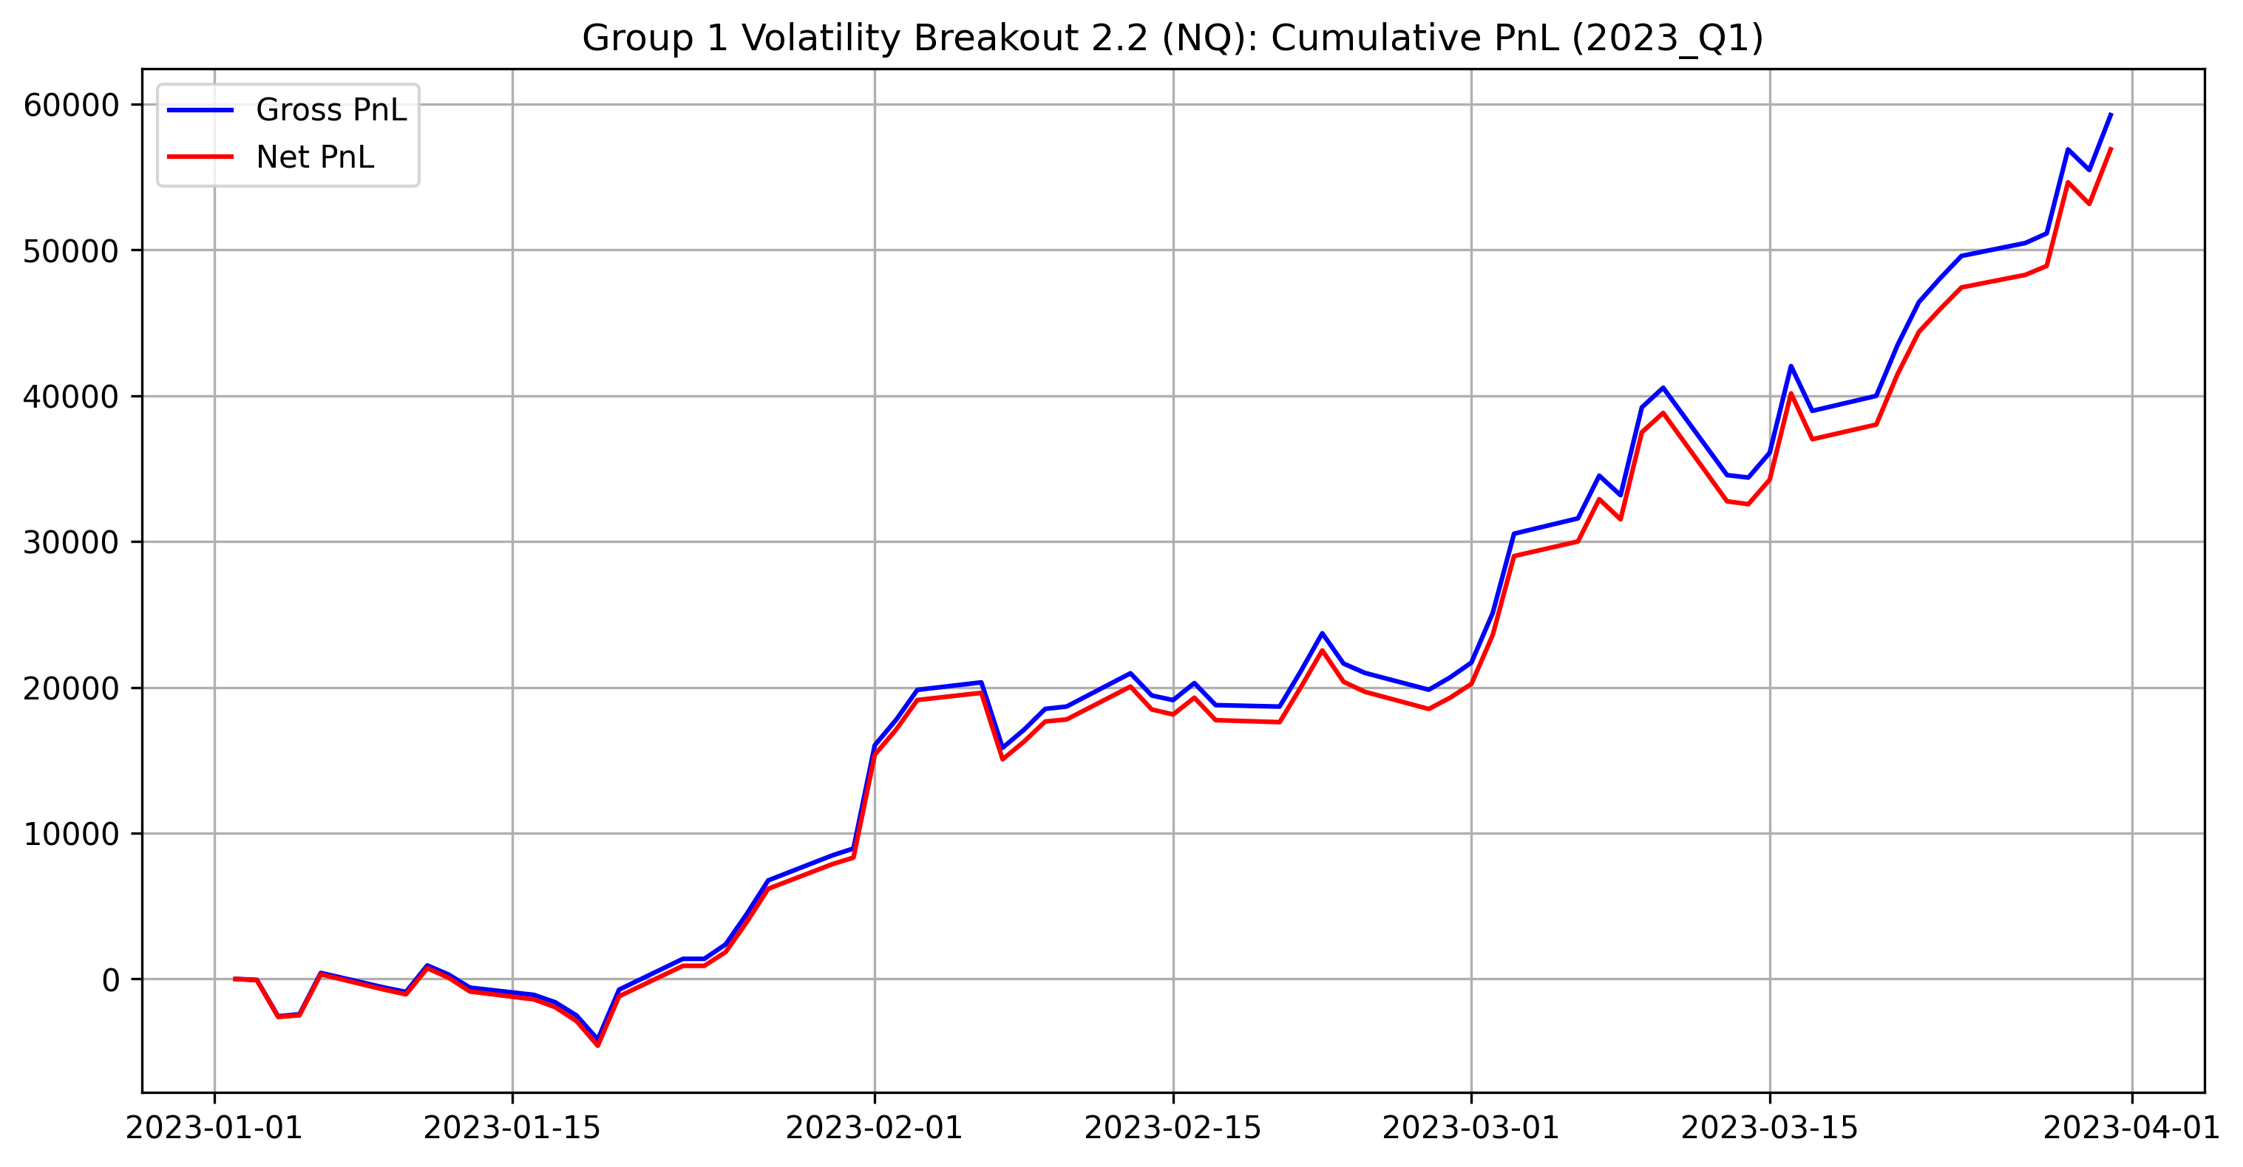

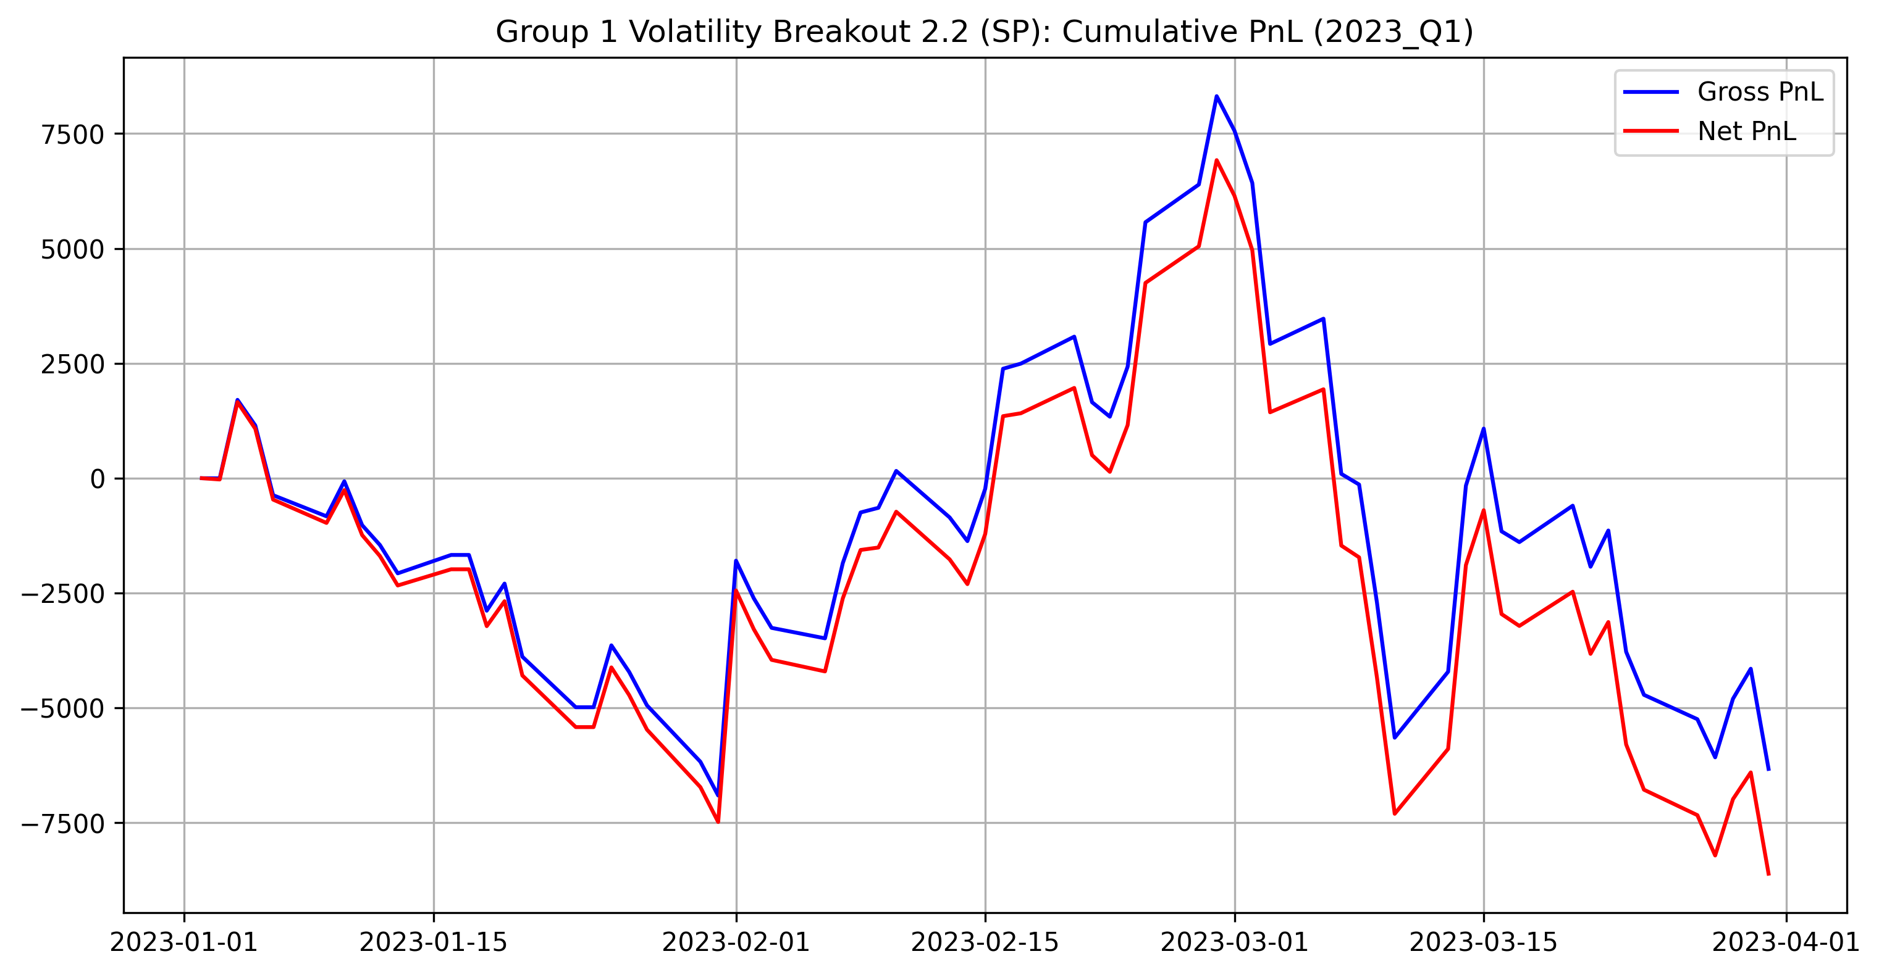

**NQ (MOM) – 2023Q1:** Strong quarter with a sustained positive net equity drift. The breakout component benefits from persistent directional moves, and the gap between gross and net is present but does not change the conclusion.

**SP (MR) – 2023Q1:** Weak/negative quarter. Mean-reversion signals struggle when moves are persistent or when reversals are not clean; the cost drag further worsens the net equity line.

## Equity line for **group 1** – 2023Q2

**Comment:** 2023Q2 was not included in the current Group 1 evaluation run/output set. If required, add the quarter to the quarters list in final\_strategy\_group1.py and re-render.

## Equity line for **group 1** – 2023Q3

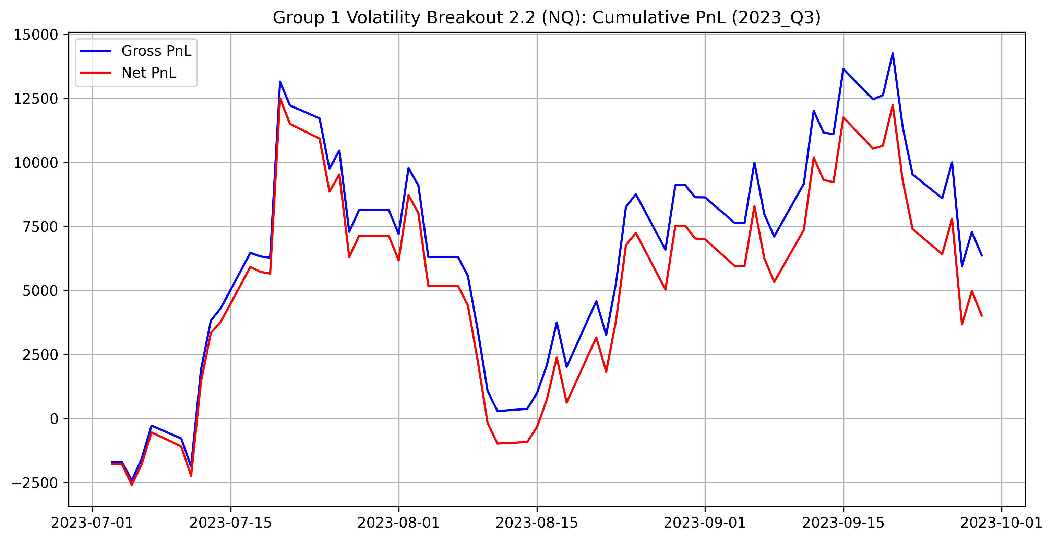

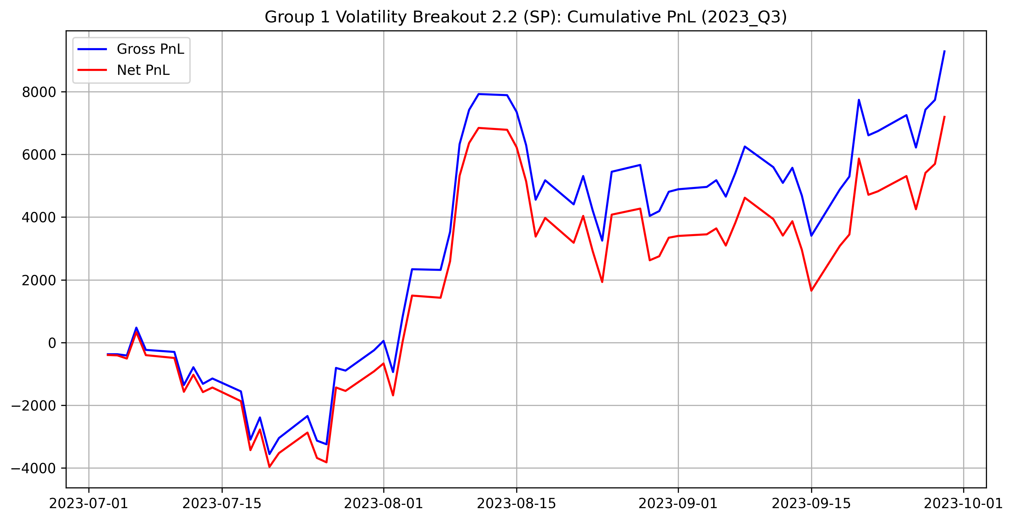

**NQ (MOM) – 2023Q3:** Lower-edge quarter for momentum: equity is flatter with smaller gains and longer stagnant periods. In these conditions, the turnover/cost drag becomes more visible relative to the signal edge.

**SP (MR) – 2023Q3:** Clear positive quarter. A more two‑sided/oscillating regime supports mean‑reversion entries, producing a steadier net equity climb.

## Equity line for **group 1** – 2023Q4

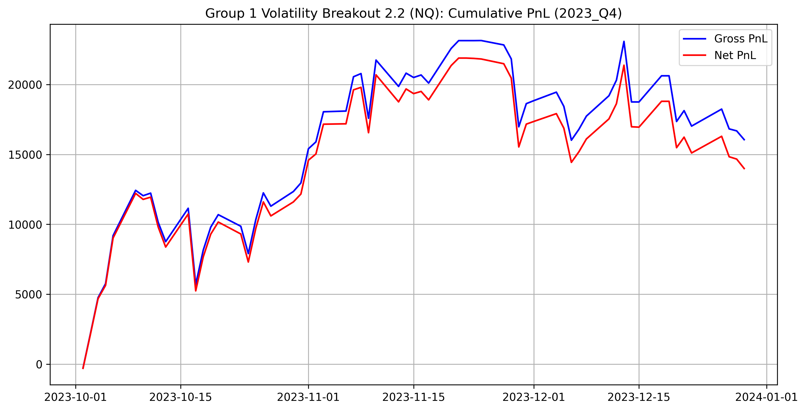

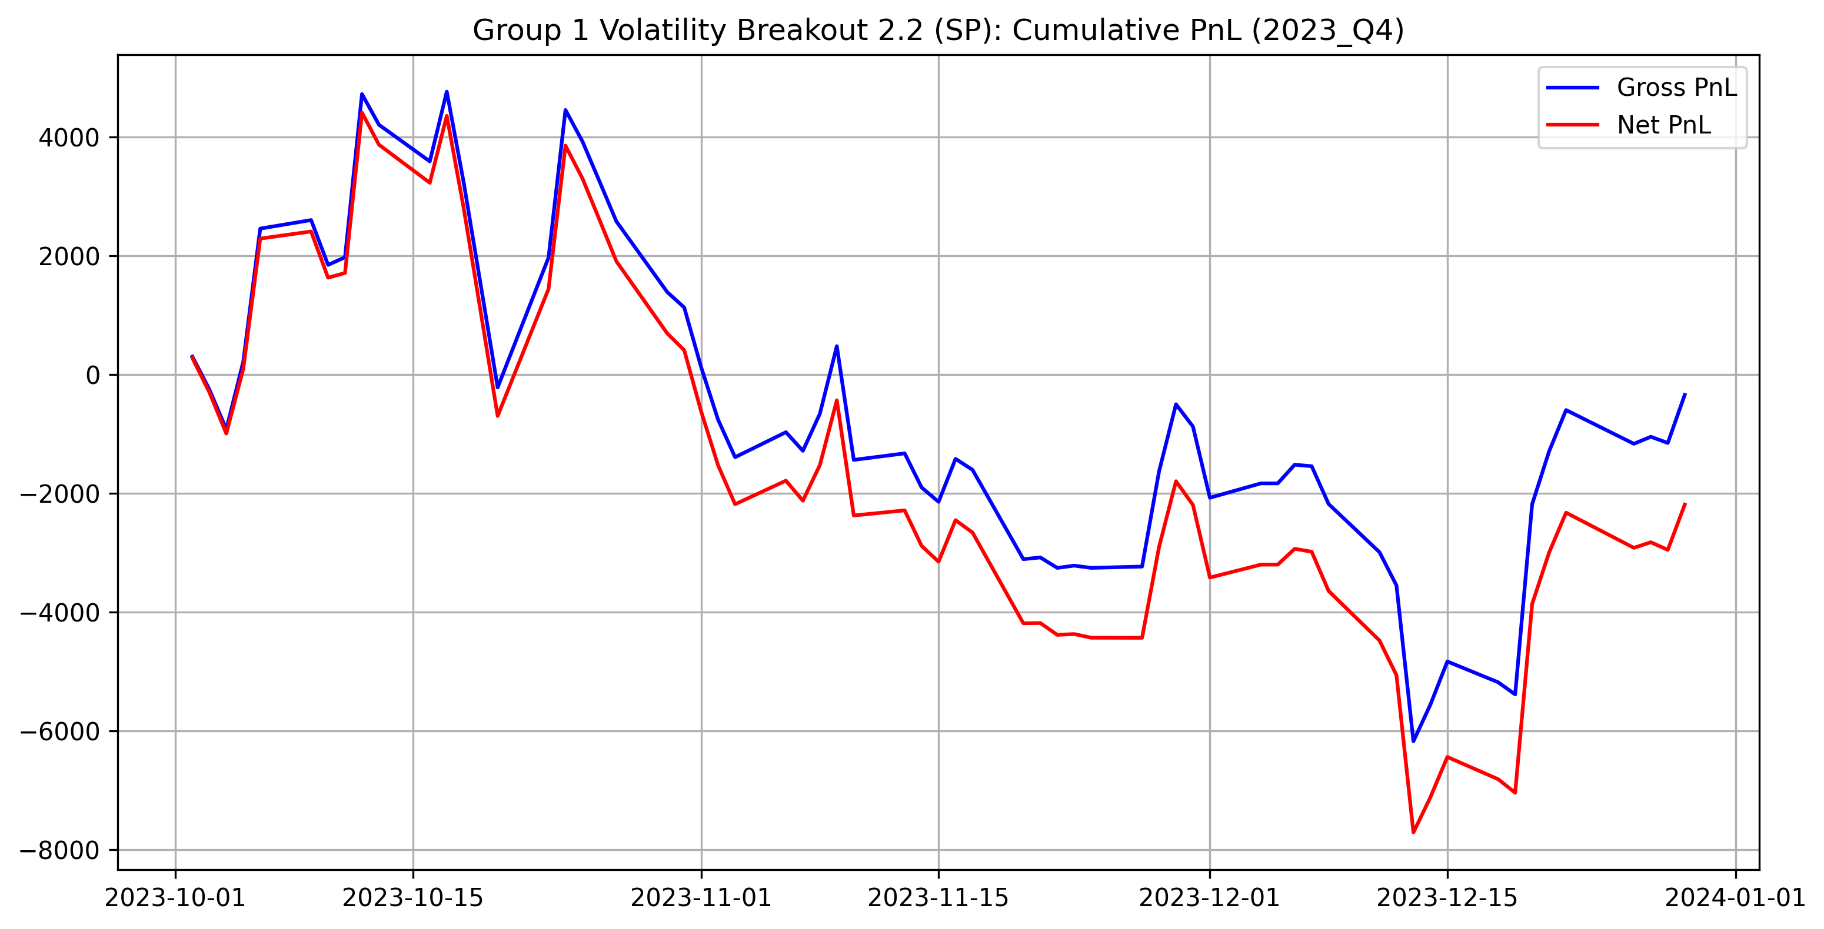

**NQ (MOM) – 2023Q4:** Good quarter for breakouts, with net equity increasing through multiple trend episodes. Drawdowns exist but are recovered as trends persist long enough to offset costs.

**SP (MR) – 2023Q4:** Slightly negative/flat overall. Mean‑reversion opportunities are either weaker or get interrupted by directional moves, leading to a net profile where costs can dominate.

## Equity line for **group 1** – 2024Q1

**Comment:** 2024Q1 was not included in the current Group 1 evaluation run/output set.

## Equity line for **group 1** – 2024Q2

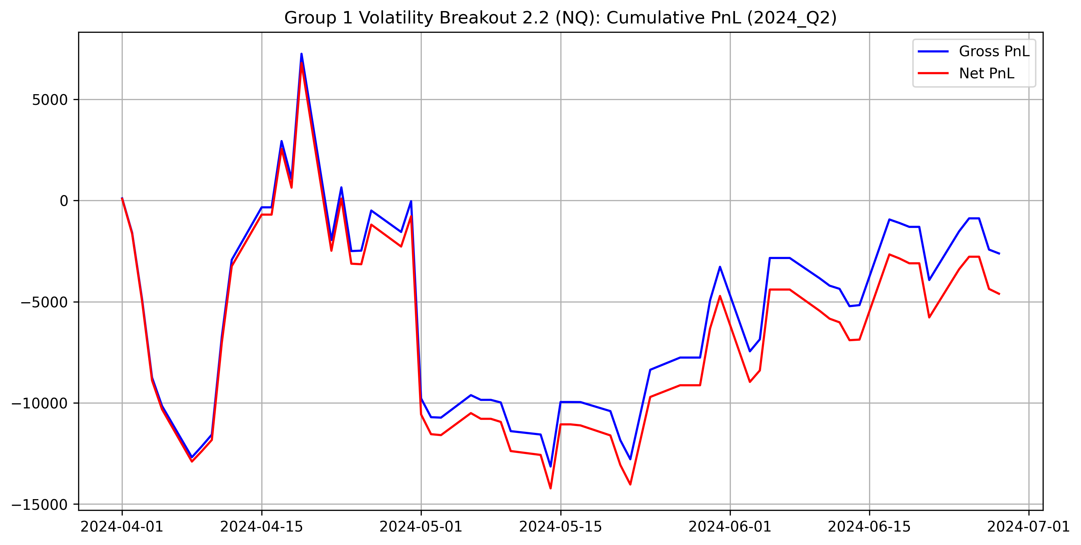

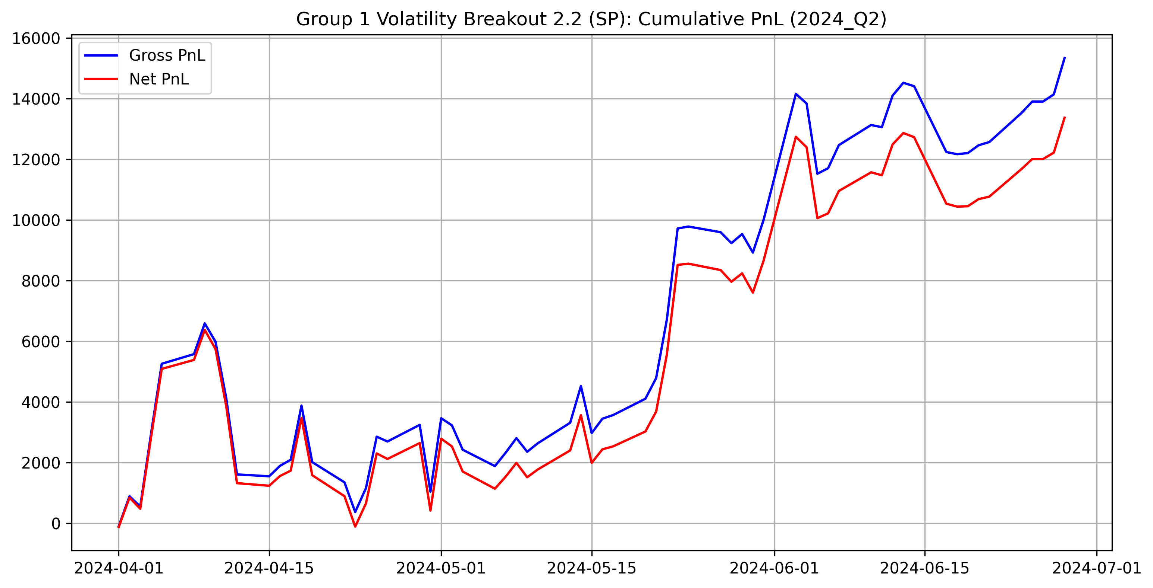

**NQ (MOM) – 2024Q2:** Challenging quarter for momentum; choppy/mean‑reverting price action tends to trigger breakouts that fail, creating drawdowns.

**SP (MR) – 2024Q2:** One of the strongest quarters for the mean‑reversion leg. Repeated reversals allow the strategy to monetize noise around the slow EMA center while keeping net performance robust after costs.

## Equity line for **group 1** – 2024Q3

**Comment:** 2024Q3 was not included in the current Group 1 evaluation run/output set.

## Equity line for **group 1** – 2024Q4

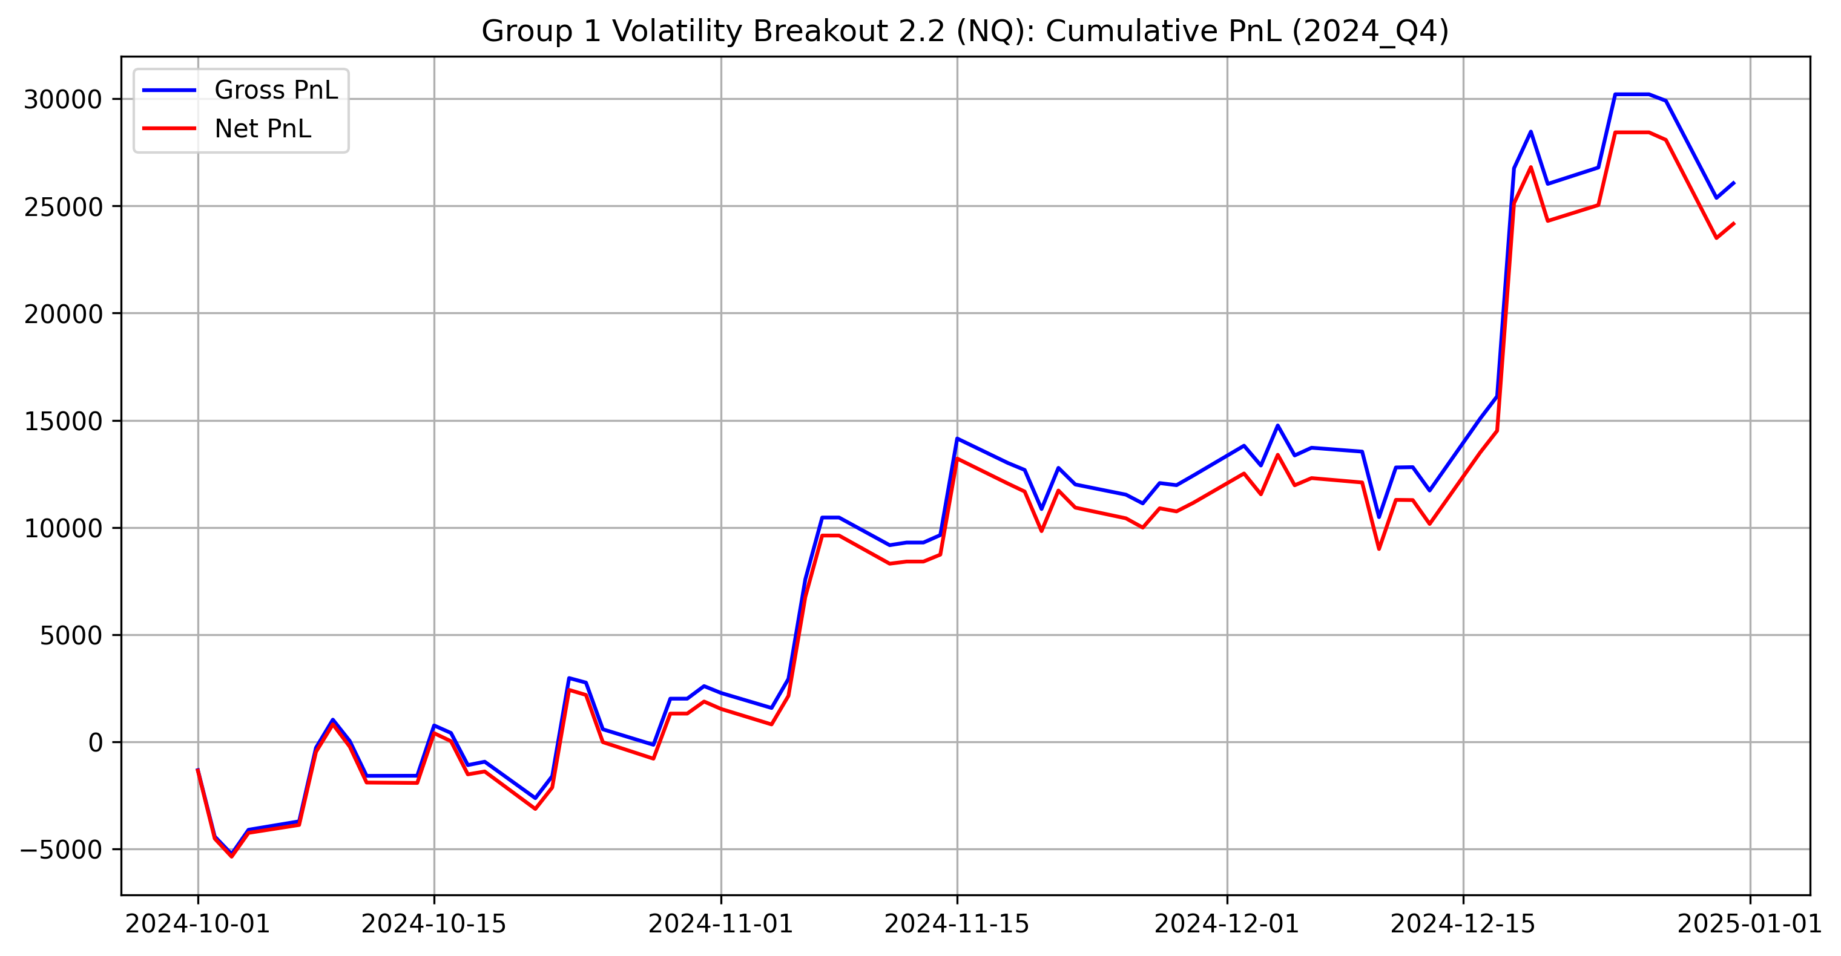

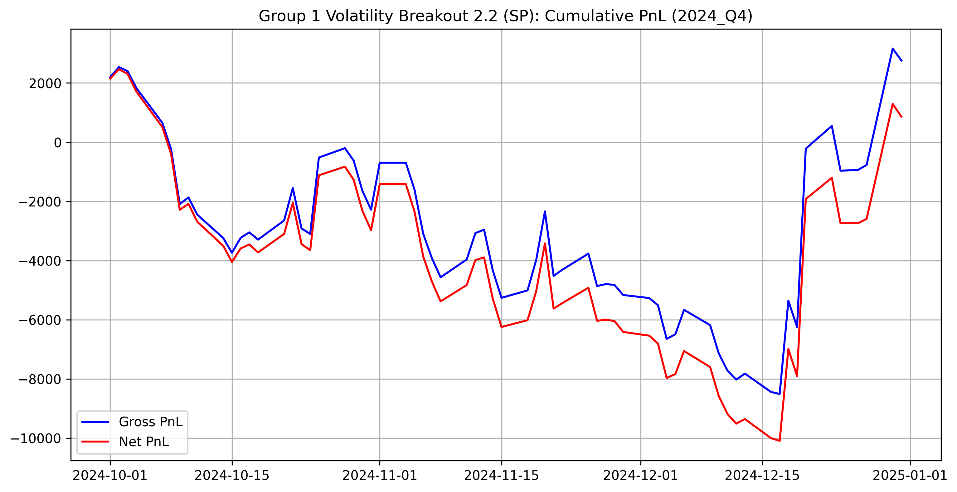

**NQ (MOM) – 2024Q4:** Strong quarter with pronounced positive net drift, consistent with sustained moves that favor breakouts.

**SP (MR) – 2024Q4:** Near-flat/slightly positive quarter. Gross gains are relatively small and transaction costs consume a meaningful part of the edge.

## Equity line for **group 1** – 2025Q1

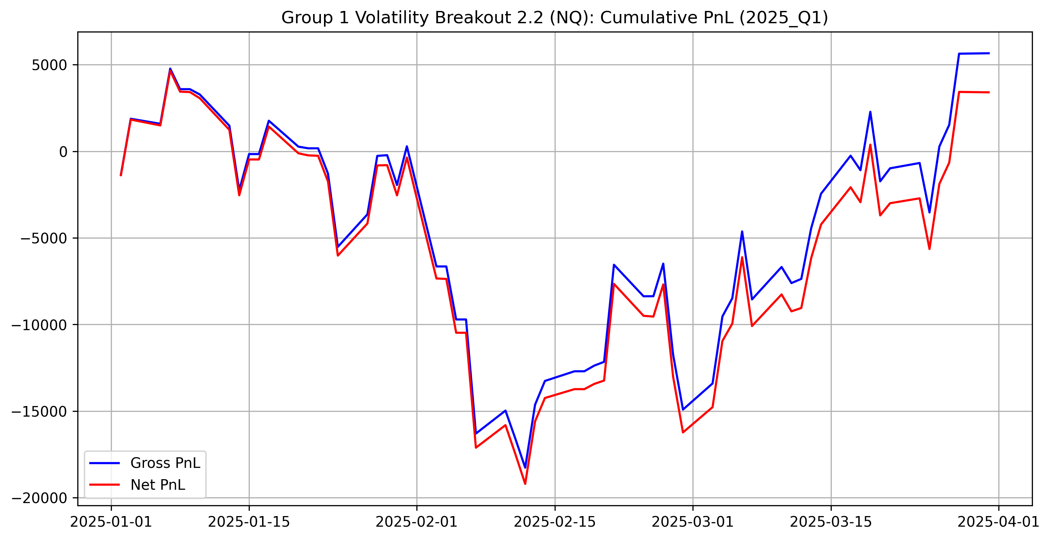

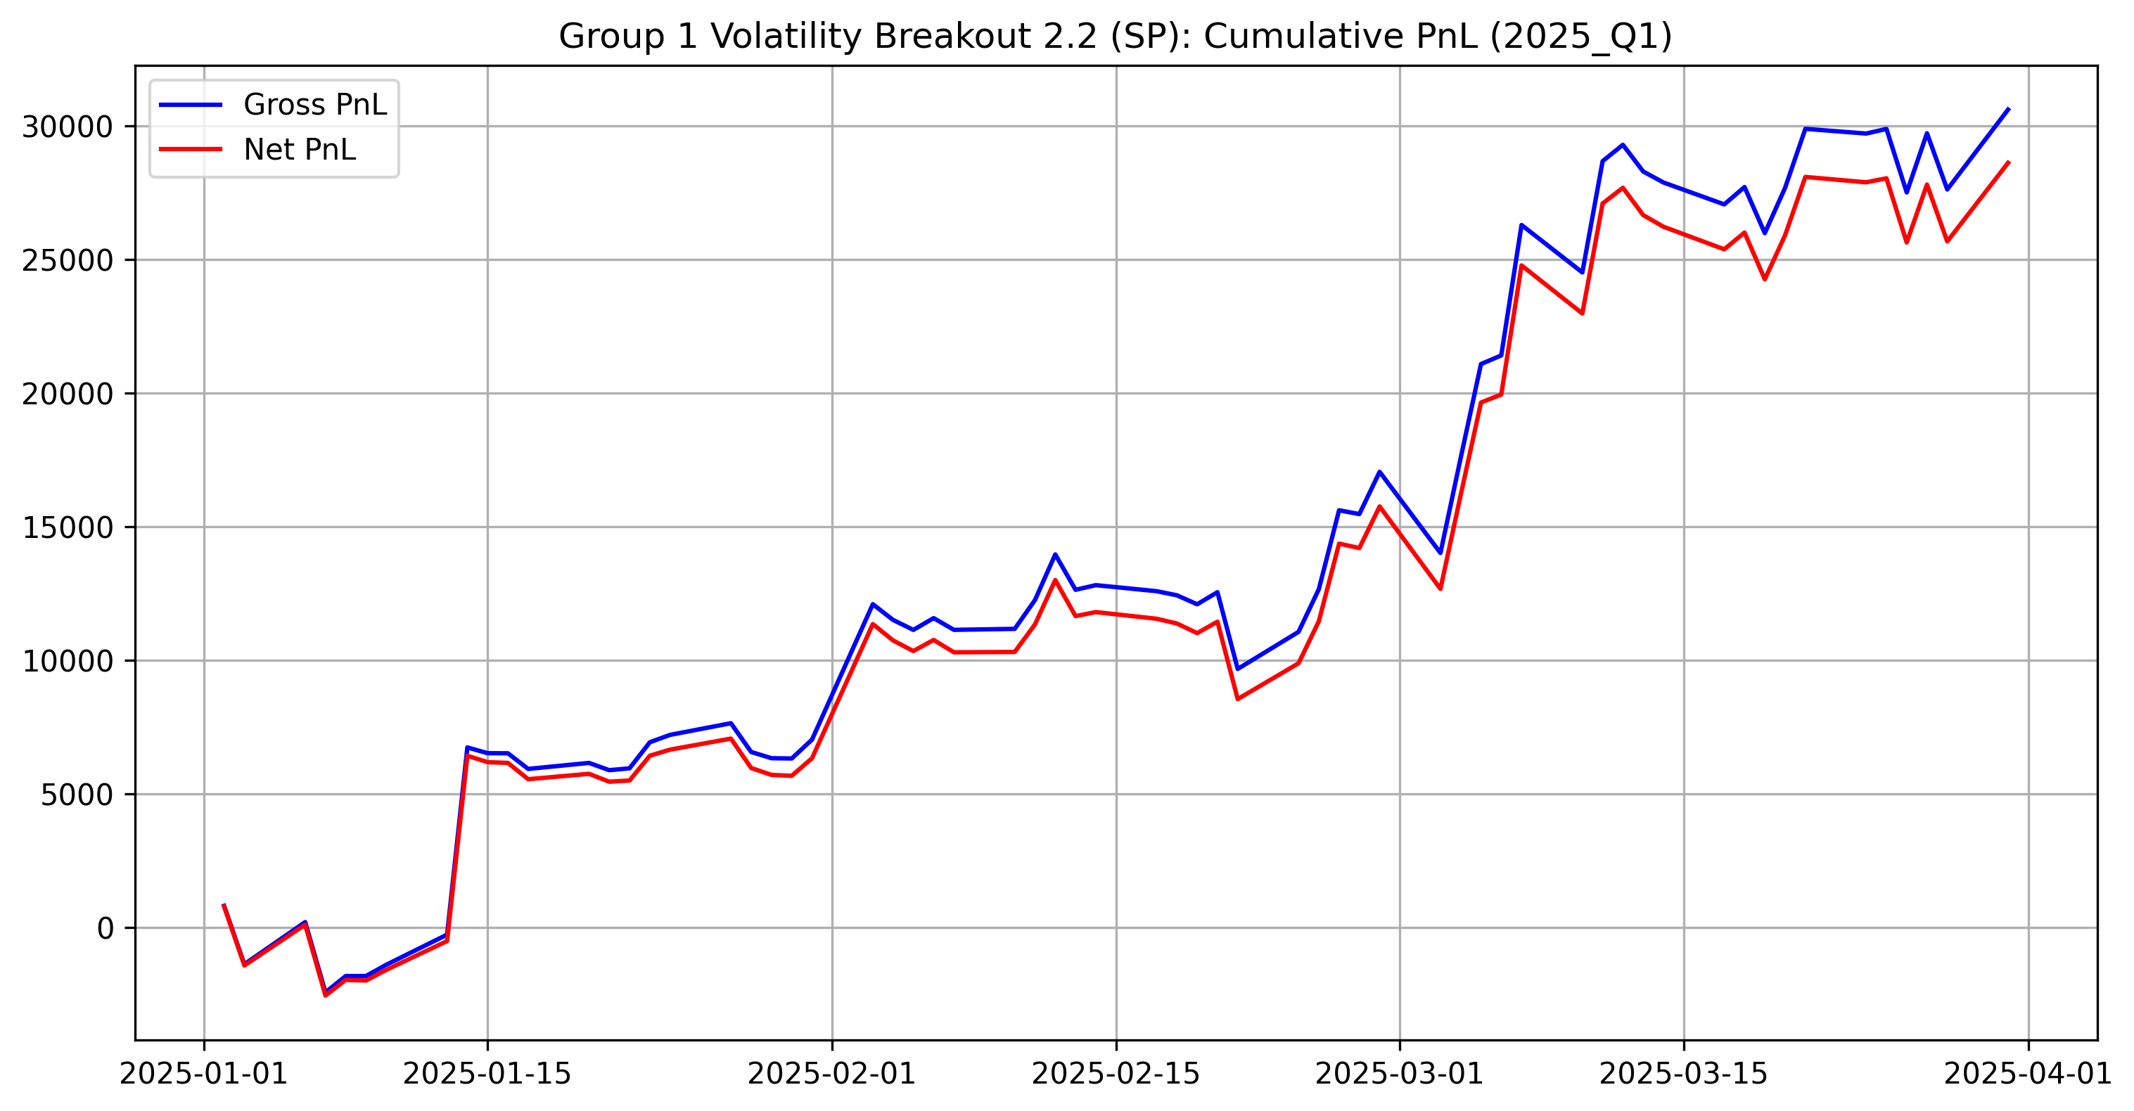

**NQ (MOM) – 2025Q1:** Modest positive quarter. Momentum edge is present but smaller than in the strongest trend regimes; net still benefits from periods of sustained movement.

**SP (MR) – 2025Q1:** Very strong quarter for mean‑reversion. The equity profile indicates frequent, profitable reversals where the strategy can scale gains beyond the cost drag.

## Equity line for **group 1** – 2025Q2

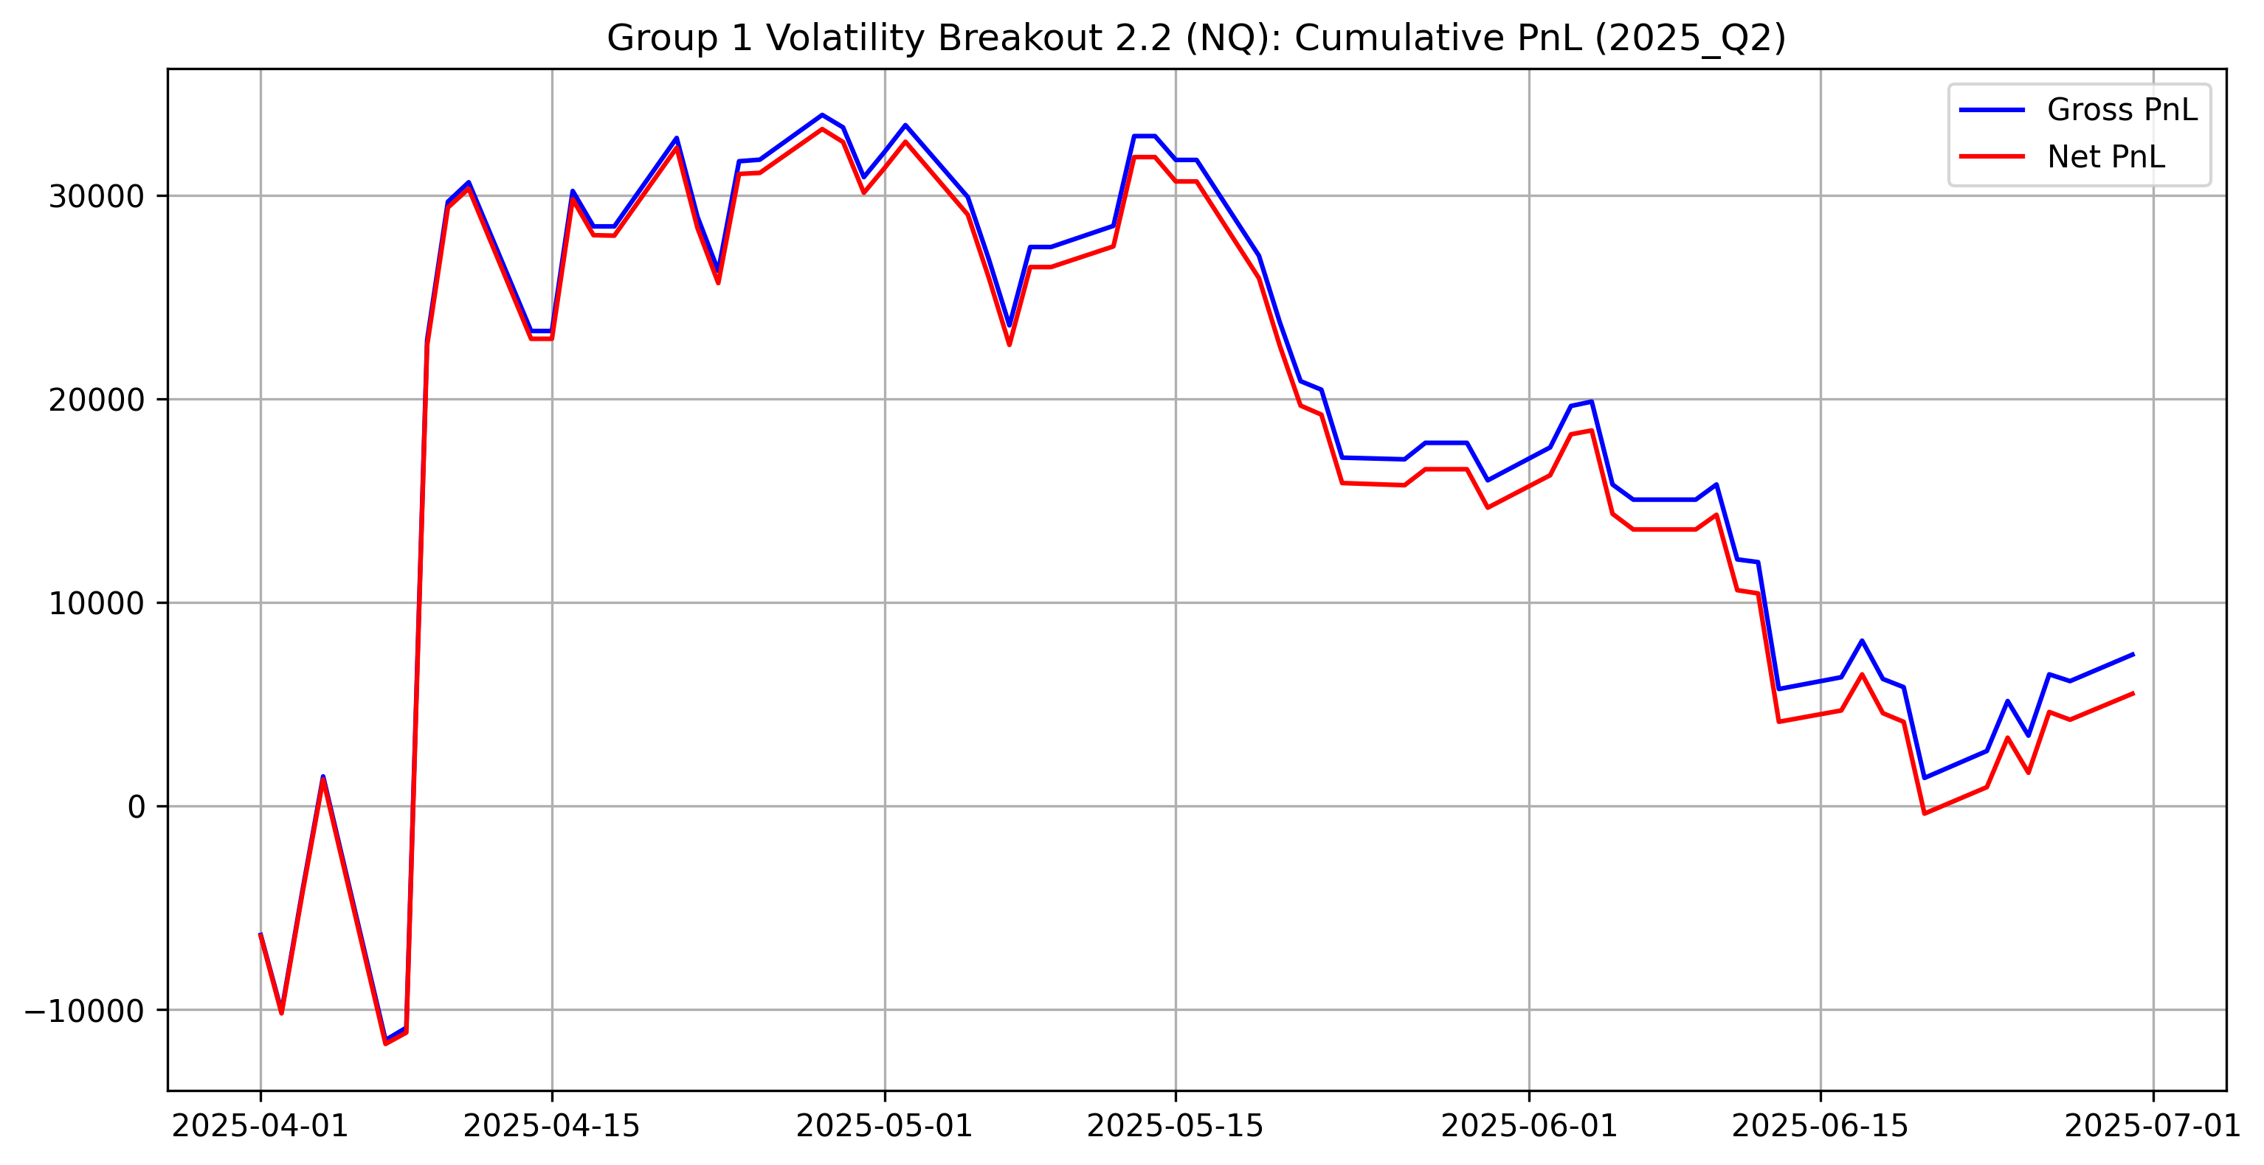

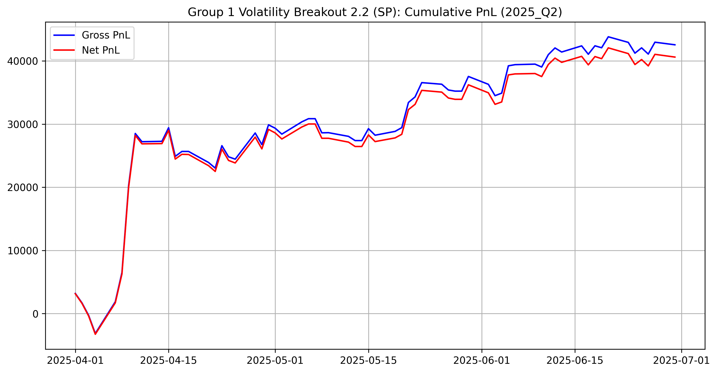

**NQ (MOM) – 2025Q2:** Positive but lower-edge quarter: the net curve rises more gradually and shows sensitivity to transaction costs during sideways stretches.

**SP (MR) – 2025Q2:** Strong quarter again; the mean‑reversion leg remains the dominant contributor with a relatively stable net trajectory.

## Equity line for **group 1** – 2025Q3

**Comment:** 2025Q3 was not included in the current Group 1 evaluation run/output set.

## Equity line for **group 1** – 2025Q4

**Comment:** 2025Q4 was not included in the current Group 1 evaluation run/output set.

# Group 2

## Approaches undertaken

For Group 2 **(Gold - XAU, Silver - XAG)**, we faced different challenges compared to Group 1: specific trading hours (Sunday-Friday), a daily break (17:00-18:00 CET), and significantly higher fixed transaction costs ($10/$15) relative to tick value. We tested two primary logic families on 5-minute data.

## Strategies considered

**Strategy 1 - Volatility Breakout**

* **Signal:** We adapted the Donchian Channel logic for close-only data.
* **Entry:**
  + Enter Long if $Close_{t}>Max\left(Close_{t−1}...Close_{t−n}\right)$.
  + Enter Short if $Close_{t}<Min\left(Close_{t−1}...Close_{t−n}\right)$.
* **Volatility Filter:** Trades are only taken if the rolling standard deviation of price changes exceeds a threshold (vol\_threshold). This prevents trading during “dead” markets where the fixed transaction cost would exceed potential profit.
* **Regime Filter (Session):** We tested applying the strategy **24 hours** vs. **US Session Only** (13:00–16:30 CET).

**Strategy 2 - EMA Crossover + RSI**

* **Signal:** Standard Fast/Slow EMA crossover.
* **Filter:** RSI (Relative Strength Index) was added to filter out overextended moves.
  + *Long Rule:* Fast > Slow AND RSI < 70 (Not Overbought).
  + *Short Rule:* Fast < Slow AND RSI > 30 (Not Oversold).
* **Hypothesis:** We tested if smoothing the noisy 5-minute data with EMAs would reduce the “whipsaw” effect seen in precious metals.

## Assumptions / execution rules

* **Timezone Management:** All data was converted from UTC to CET to strictly adhere to the project’s time-specific rules.
* **Forced Exits:** All positions are flattened daily at 16:50 CET. No trading occurs during the break (17:00–18:00) or the first 10 minutes after re-open (18:00–18:10).
* **Transaction Costs:** We applied $15 per trade for Gold and $10 per trade for Silver.

## Parameter search & selection

1. **Global Optimization:** Unlike Group 1, we performed a cross-product grid search. We tested every combination of Gold parameters against every combination of Silver parameters to find the best portfolio score, rather than optimizing assets in isolation.
2. **Grid Space:**
   * Window (Lookback): [24, 48, …, 288 (24 hours)]
   * Vol\_Threshold: [0.03, 0.05, …, 1.5]
   * Session: [‘Full’, ‘US\_Only’]
3. **Selection Criterion:** Maximizing the sum of the project statistic across all in-sample quarters.

## Finally selected strategy

**Hybrid Volatility Breakout**

Based on the in-sample optimization, the Breakout logic significantly outperformed the EMA approach (which suffered from lag and high turnover costs). The final selected portfolio is “Hybrid” because it applies different time-regimes to each metal:

* **Gold (XAU):**
  + **Parameters:** Window=288 (24 hours), Vol\_Threshold=0.5, Session=Full.
  + *Logic:* Gold has deep global liquidity. A 24-hour lookback filters intraday noise, allowing the strategy to capture major macro trends overnight.
* **Silver (XAG):**
  + **Parameters:** Window=144 (12 hours), Vol\_Threshold=0.05, Session=US\_Only.
  + *Logic:* Silver is noisier. By restricting new entries to the US Session (13:00–16:30 CET), we avoid false signals during low-volume European mornings.

## Summary of results

| quarter | sym | gross\_SR | net\_SR | gross\_PnL | net\_PnL | gross\_CR | net\_CR | av\_daily\_ntrans | stat |
| --- | --- | --- | --- | --- | --- | --- | --- | --- | --- |
| 2023\_Q1 | XAG | nan | nan | 0.00 | 0.00 | nan | nan | 0.00 | nan |
| 2023\_Q1 | XAU | 0.09 | -0.19 | 659.80 | -1470.20 | 0.16 | -0.32 | 1.60 | -0.27 |
| 2023\_Q2 | XAG | -0.20 | -0.30 | -80.00 | -120.00 | -0.65 | -0.94 | 0.04 | -0.00 |
| 2023\_Q2 | XAU | -1.80 | -2.17 | -9694.90 | -11749.90 | -2.88 | -3.09 | 1.54 | -6.58 |
| 2023\_Q3 | XAG | 1.69 | 1.69 | 2225.00 | 2205.00 | nan | nan | 0.02 | 0.94 |
| 2023\_Q3 | XAU | 1.61 | 1.08 | 4973.60 | 3353.60 | 4.82 | 2.94 | 1.21 | 0.70 |
| 2023\_Q4 | XAG | 2.40 | 2.39 | 1405.00 | 1365.00 | nan | nan | 0.04 | 0.59 |
| 2023\_Q4 | XAU | 2.07 | 1.72 | 11856.90 | 9876.90 | 7.59 | 6.19 | 1.48 | 2.79 |
| 2024\_Q1 | XAG | 1.67 | 1.67 | 655.00 | 635.00 | nan | nan | 0.02 | 0.00 |
| 2024\_Q1 | XAU | -0.50 | -0.82 | -3229.20 | -5269.20 | -1.27 | -1.85 | 1.49 | -2.19 |
| 2024\_Q2 | XAG | 1.98 | 1.90 | 6355.00 | 6095.00 | 5.49 | 5.18 | 0.29 | 2.53 |
| 2024\_Q2 | XAU | -0.29 | -0.54 | -2758.00 | -5158.00 | -0.54 | -0.98 | 1.76 | -1.71 |
| 2024\_Q3 | XAG | 1.30 | 1.23 | 4065.00 | 3825.00 | 6.55 | 6.07 | 0.26 | 0.97 |
| 2024\_Q3 | XAU | 2.86 | 2.59 | 22526.80 | 20366.80 | 14.89 | 11.88 | 1.57 | 6.28 |
| 2024\_Q4 | XAG | -1.03 | -1.11 | -1740.00 | -1880.00 | -1.98 | -2.07 | 0.15 | -1.02 |
| 2024\_Q4 | XAU | 3.43 | 3.19 | 29483.30 | 27443.30 | 13.45 | 12.03 | 1.49 | 8.91 |
| 2025\_Q1 | XAG | -0.11 | -0.16 | -90.00 | -130.00 | -0.37 | -0.53 | 0.04 | -0.00 |
| 2025\_Q1 | XAU | 2.35 | 2.10 | 20719.00 | 18544.00 | 10.05 | 8.60 | 1.61 | 4.68 |
| 2025\_Q2 | XAG | -0.72 | -0.86 | -580.00 | -700.00 | -2.66 | -3.07 | 0.13 | -0.00 |
| 2025\_Q2 | XAU | 0.67 | 0.55 | 12753.10 | 10443.10 | 2.30 | 1.79 | 1.69 | 0.11 |
| 2025\_Q3 | XAG | 0.16 | 0.06 | 280.00 | 100.00 | 0.36 | 0.13 | 0.20 | -0.00 |
| 2025\_Q3 | XAU | -0.25 | -0.43 | -3306.20 | -5661.20 | -0.64 | -1.02 | 1.71 | -1.62 |
| 2025\_Q4 | XAG | 1.71 | 1.53 | 1420.00 | 1260.00 | 2.87 | 2.51 | 0.53 | 0.24 |
| 2025\_Q4 | XAU | 2.53 | 2.43 | 21825.00 | 21000.00 | 5.73 | 5.47 | 1.83 | 5.89 |

The results highlight a distinct division of labor. Gold (XAU) acts as the primary profit engine, trading frequently with a high standard deviation but capturing the largest trends. Silver (XAG) acts as a diversifier; the strict US-session filter results in very low trade frequency (often < 0.2 trades/day), which preserves capital during choppy quarters while still participating in major volatility events.

## Equity lines

### 2023Q1

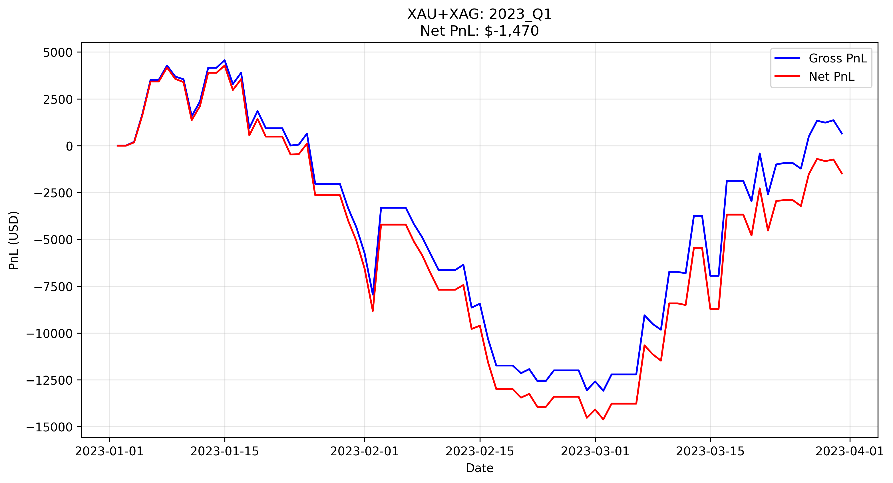

**Comment**: A challenging quarter to start. The portfolio experienced a V-shaped drawdown driven by Gold’s whipsaws in February. However, the Silver strategy’s session filter worked as intended, keeping it flat and preventing the drawdown from deepening further.

### 2023Q2 - out of sample

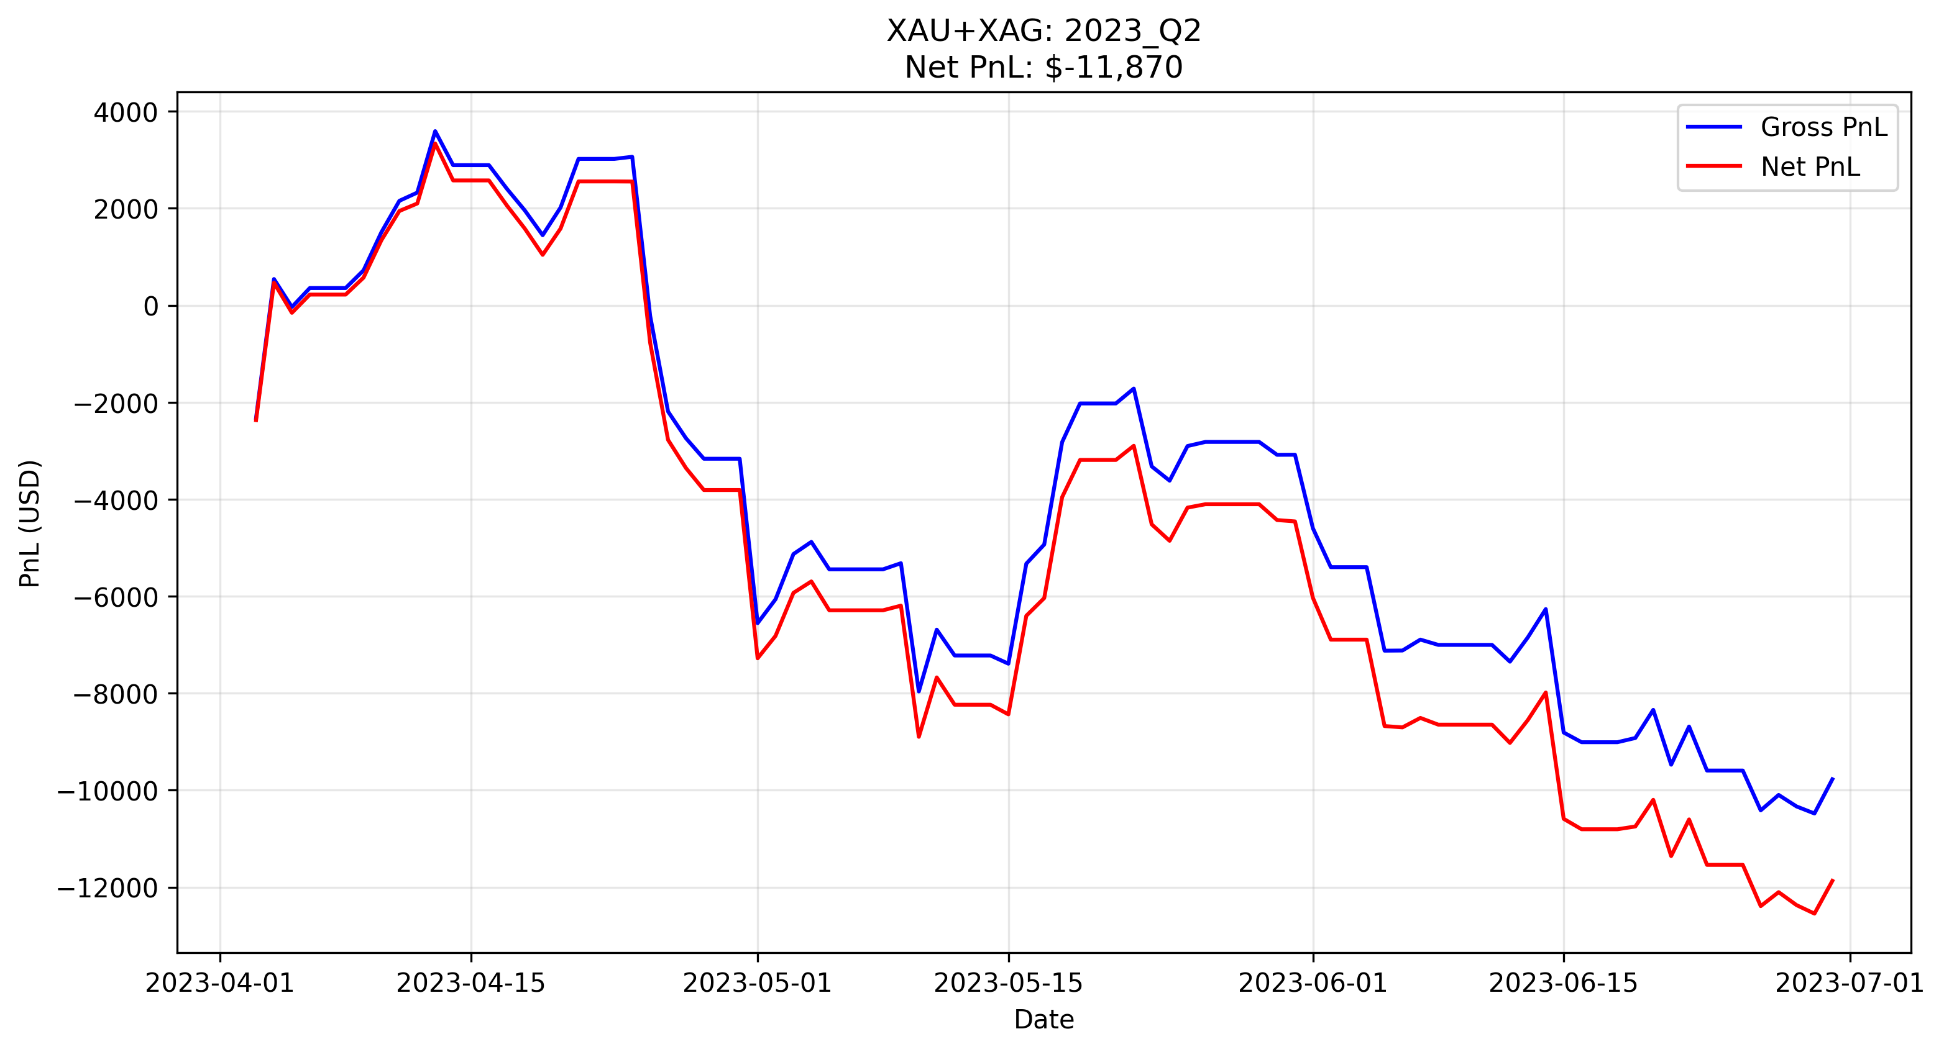

**Comment**: A difficult quarter characterized by persistent chopping. The strategy entered a drawdown early in April and struggled to recover as the market lacked sustained direction. The downward drift suggests that the “breakout” logic was frequently triggered by false moves that reversed before gaining traction.

### 2023Q3

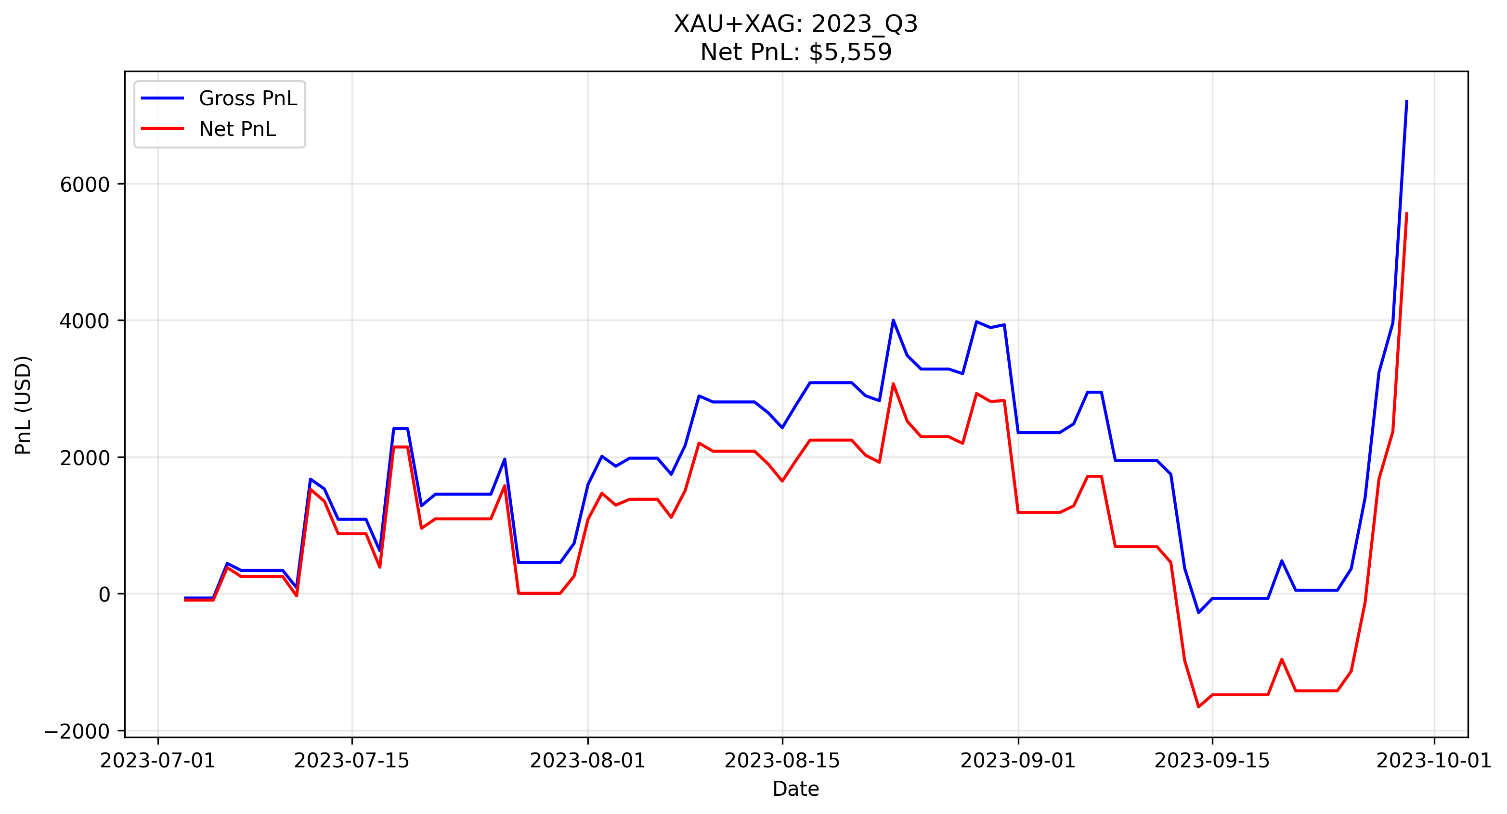

**Comment**: A solid recovery period. Both metals contributed positively, with the strategy successfully capturing a late-quarter trend. The net equity curve shows a steady, low-volatility climb, indicating the volatility filter successfully screened out the mid-quarter noise.

### 2023Q4

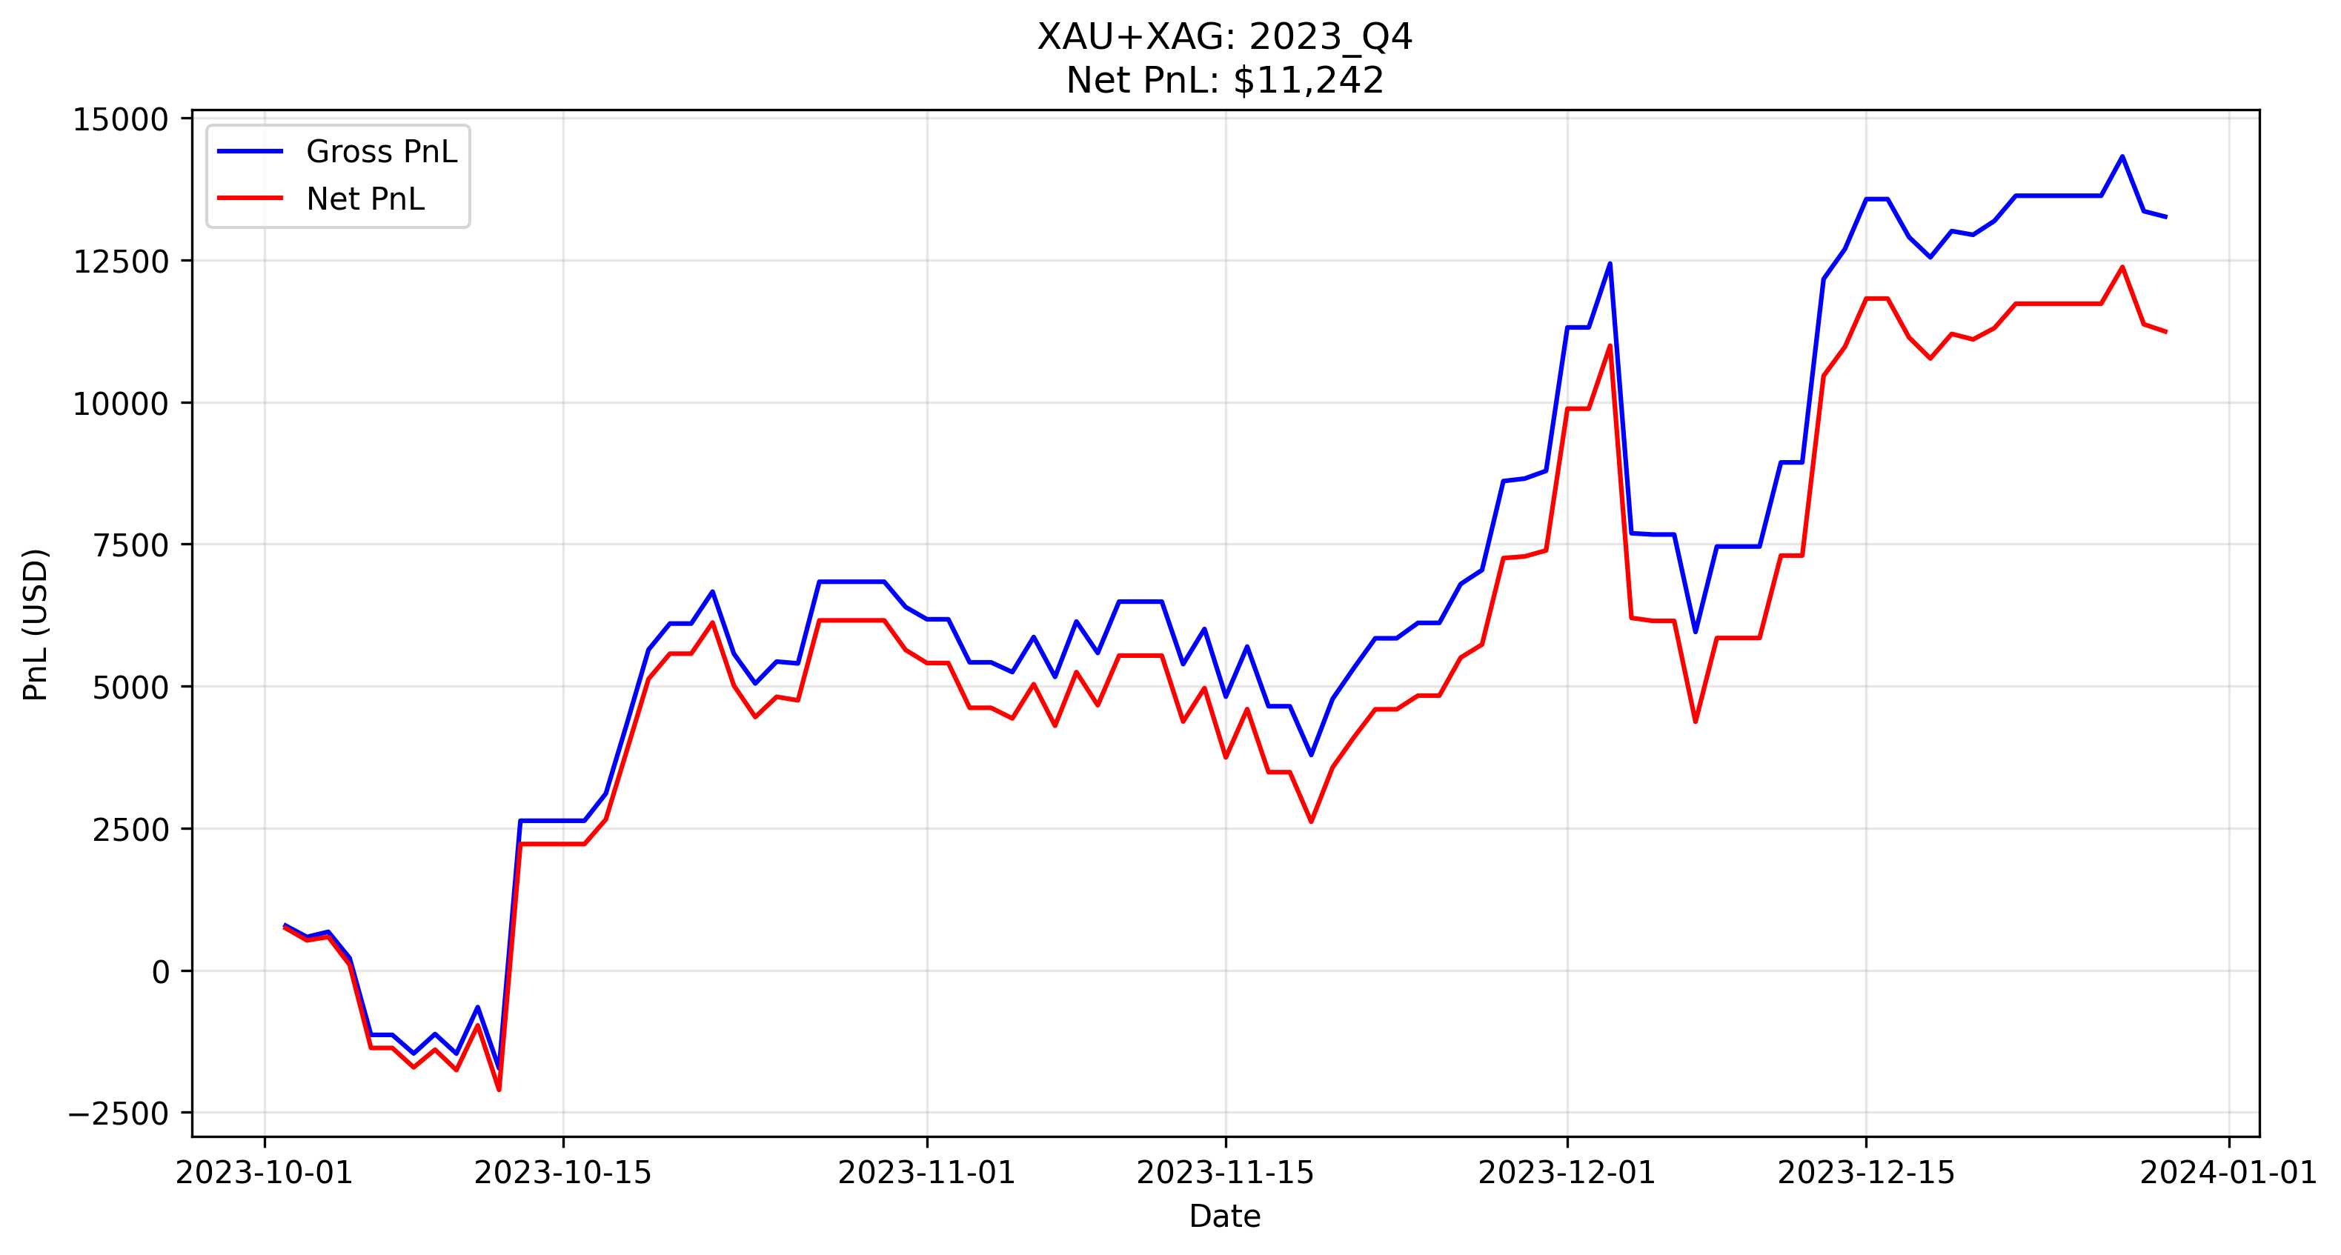

**Comment**: Strong performance driven primarily by Gold. The 24-hour breakout logic allowed the portfolio to hold a long position through overnight volatility, capturing a major multi-week trend that shorter-term strategies would have exited prematurely.

### 2024Q1 - out of sample

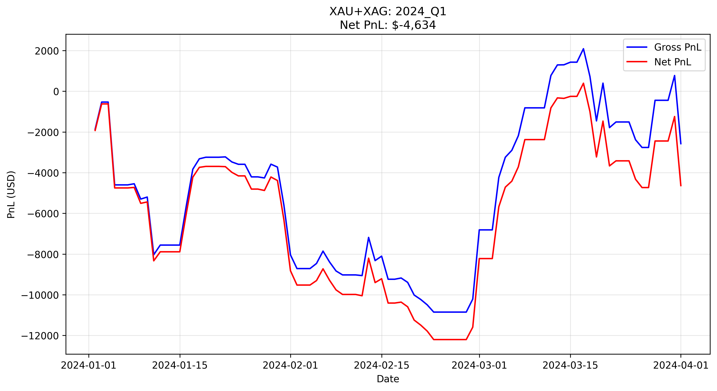

**Comment**: The quarter began with a drawdown in January and February, consistent with low-volatility consolidation. However, a strong recovery trend emerged in March, allowing the strategy to claw back losses and finish the quarter with a significantly improved equity curve, validating the “hold for the big move” philosophy.

### 2024Q2

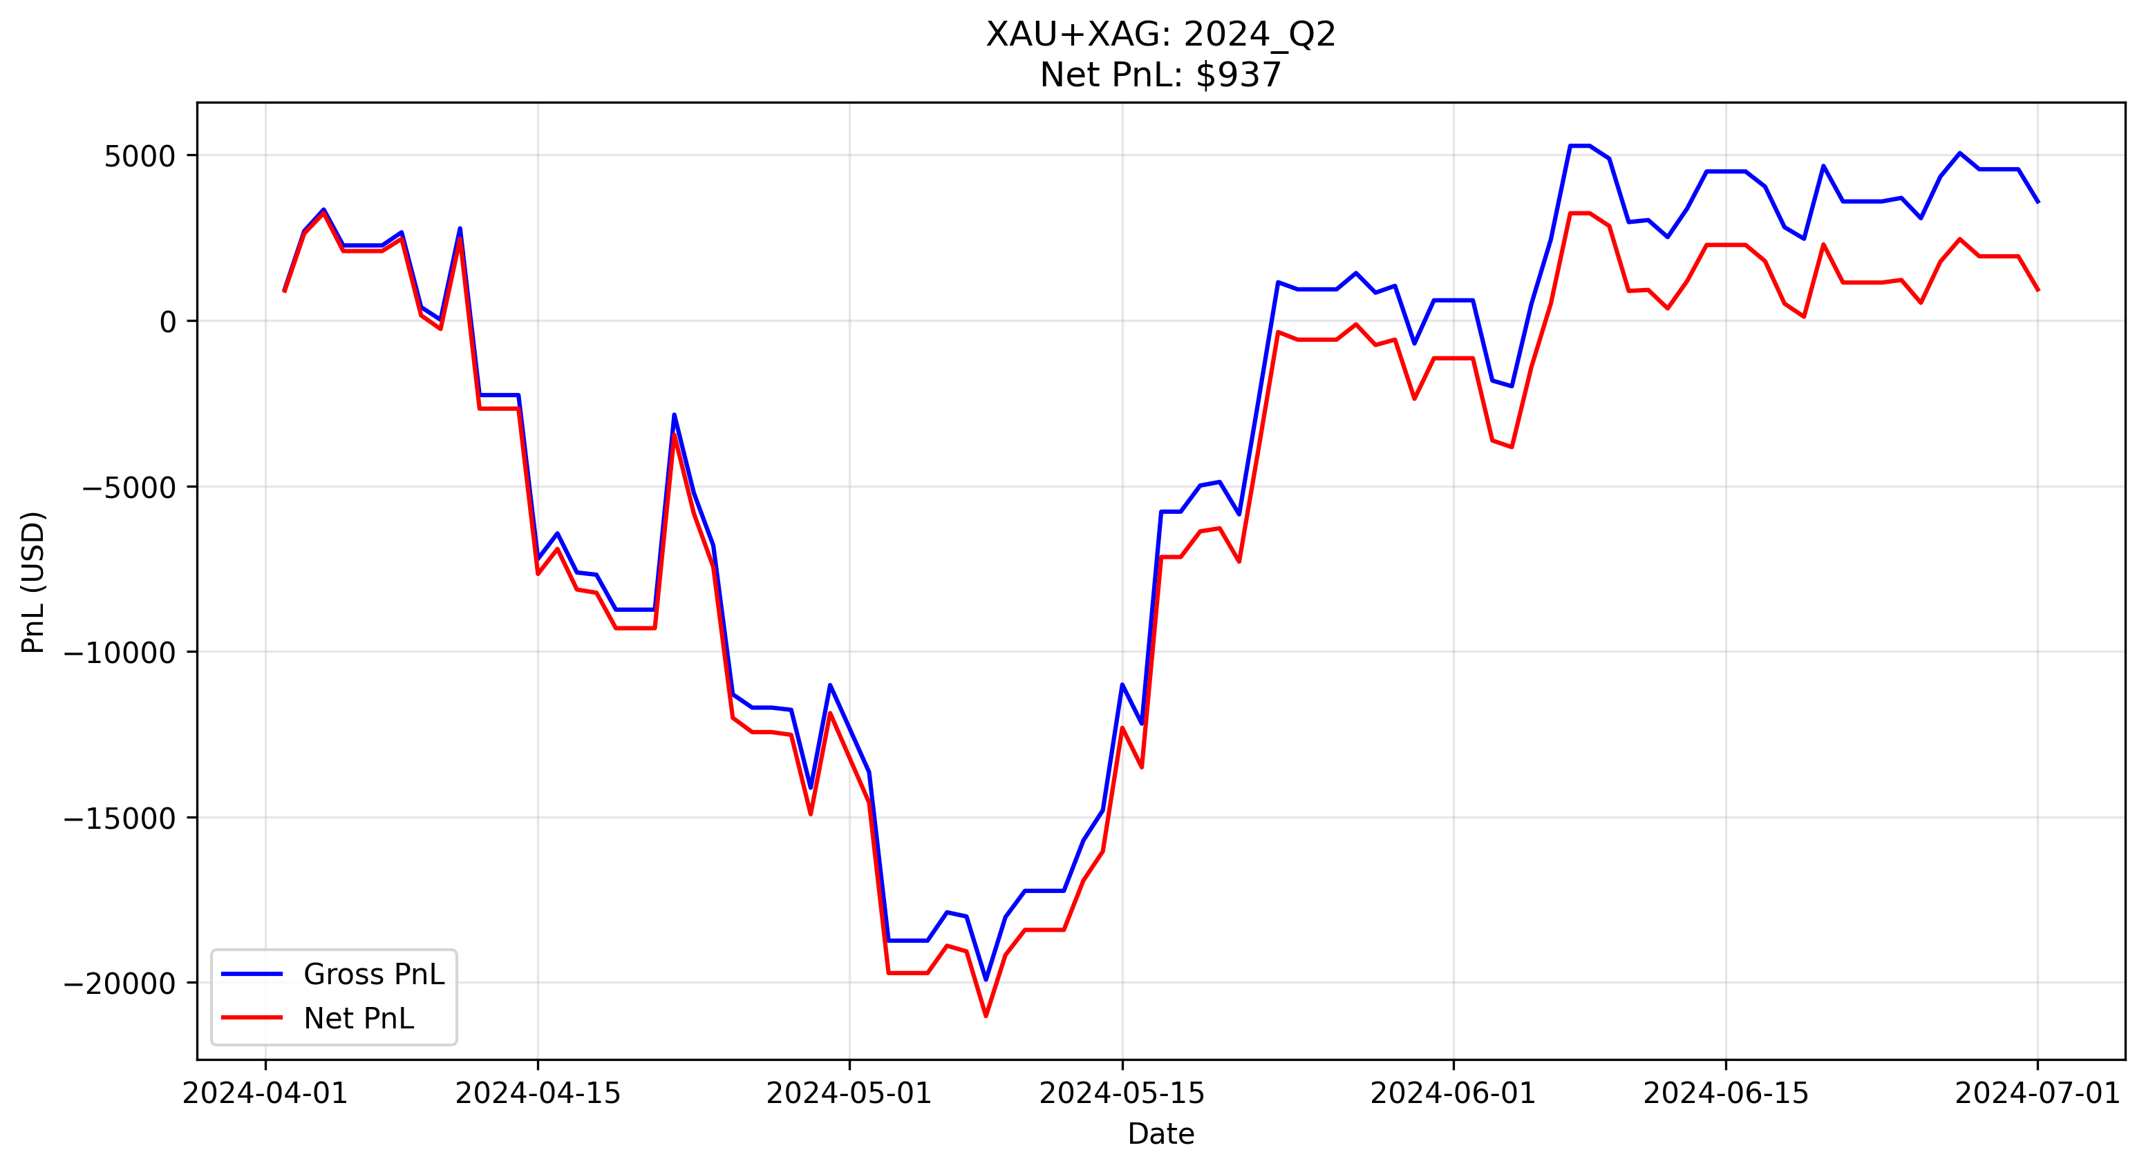

**Comment**: A prime example of portfolio synergy. While Gold struggled with choppy price action (resulting in a drawdown), Silver decoupled and generated significant profit during the US session windows, effectively stabilizing the portfolio’s overall Net PnL.

### 2024Q3 - out of sample

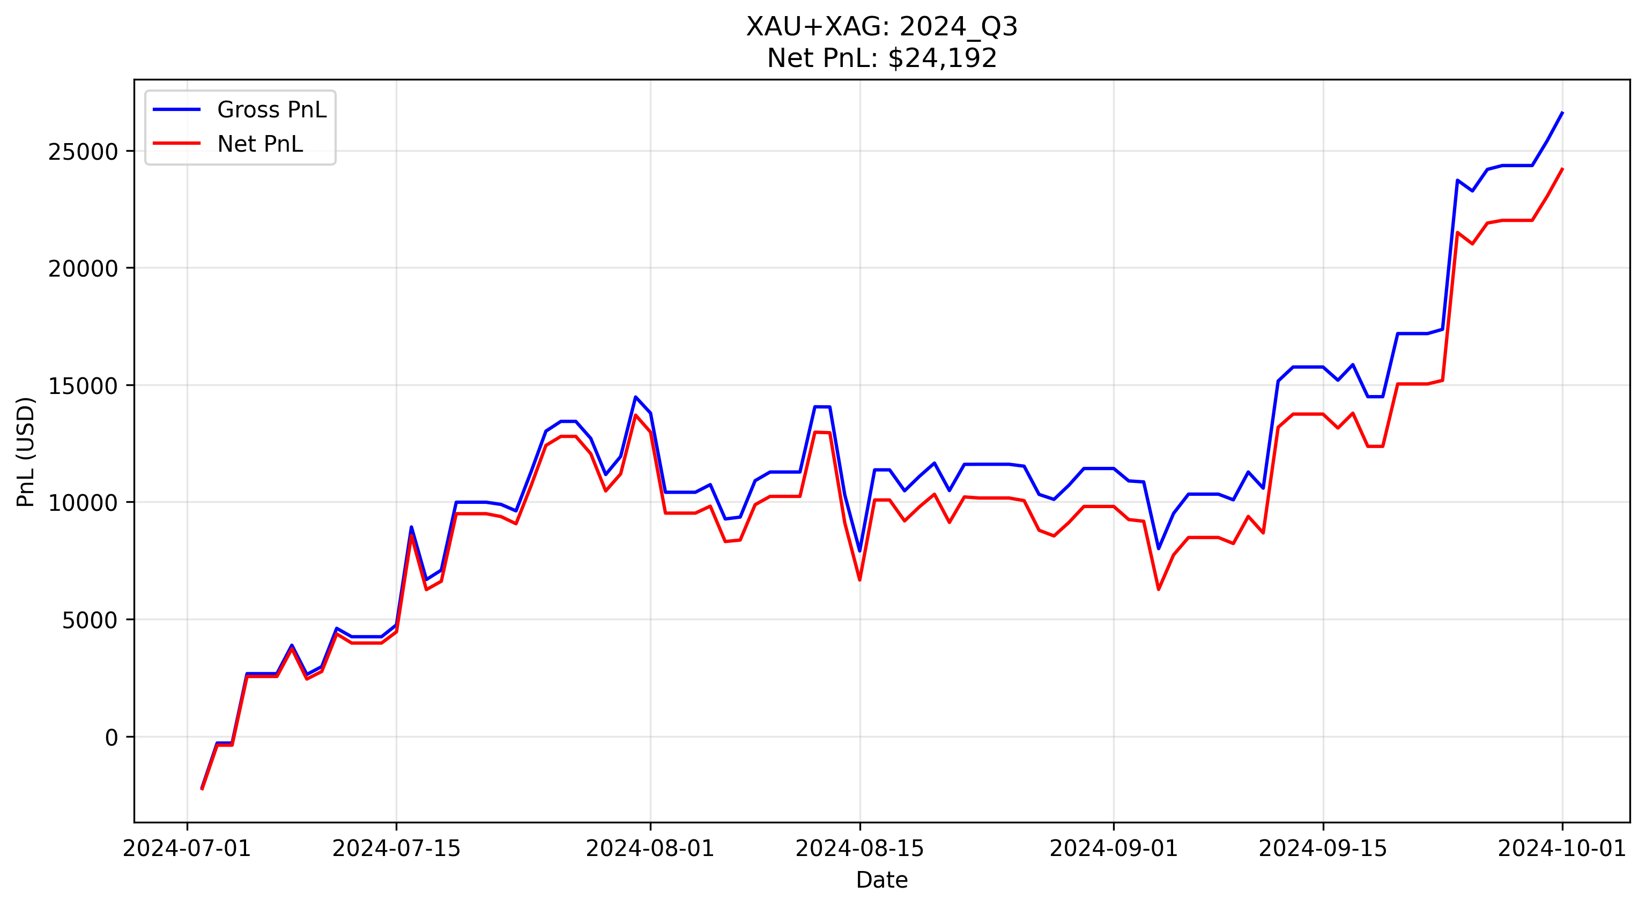

**Comment**: After a slow start in July, the portfolio captured a clean, sustained uptrend beginning in August. The steady upward slope with minimal retracement indicates a high-quality trend where both the entry logic and the volatility filter were perfectly aligned with market conditions.

### 2024Q4

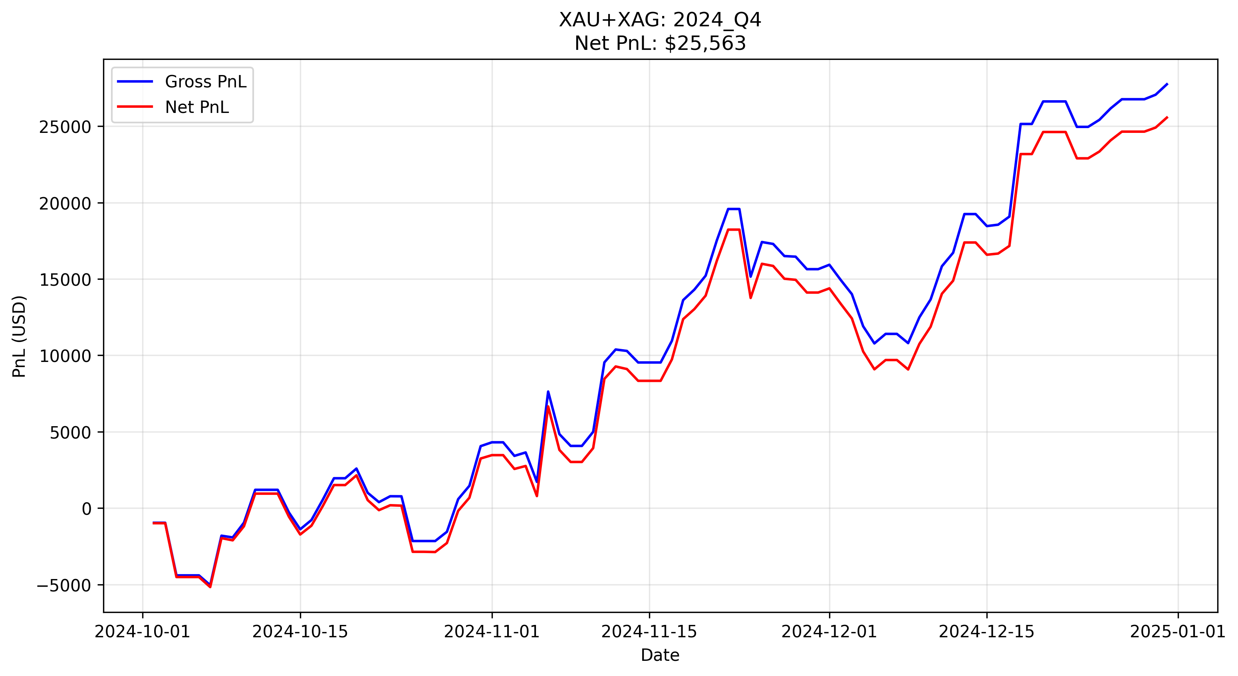

**Comment**: Exceptional performance (Highest PnL). The portfolio capitalized on a massive, unidirectional trend in Gold. The gap between Gross and Net PnL is minimal here, proving that the strategy’s wide windows (288 bars) successfully minimize turnover costs during strong trending regimes.

### 2025Q1

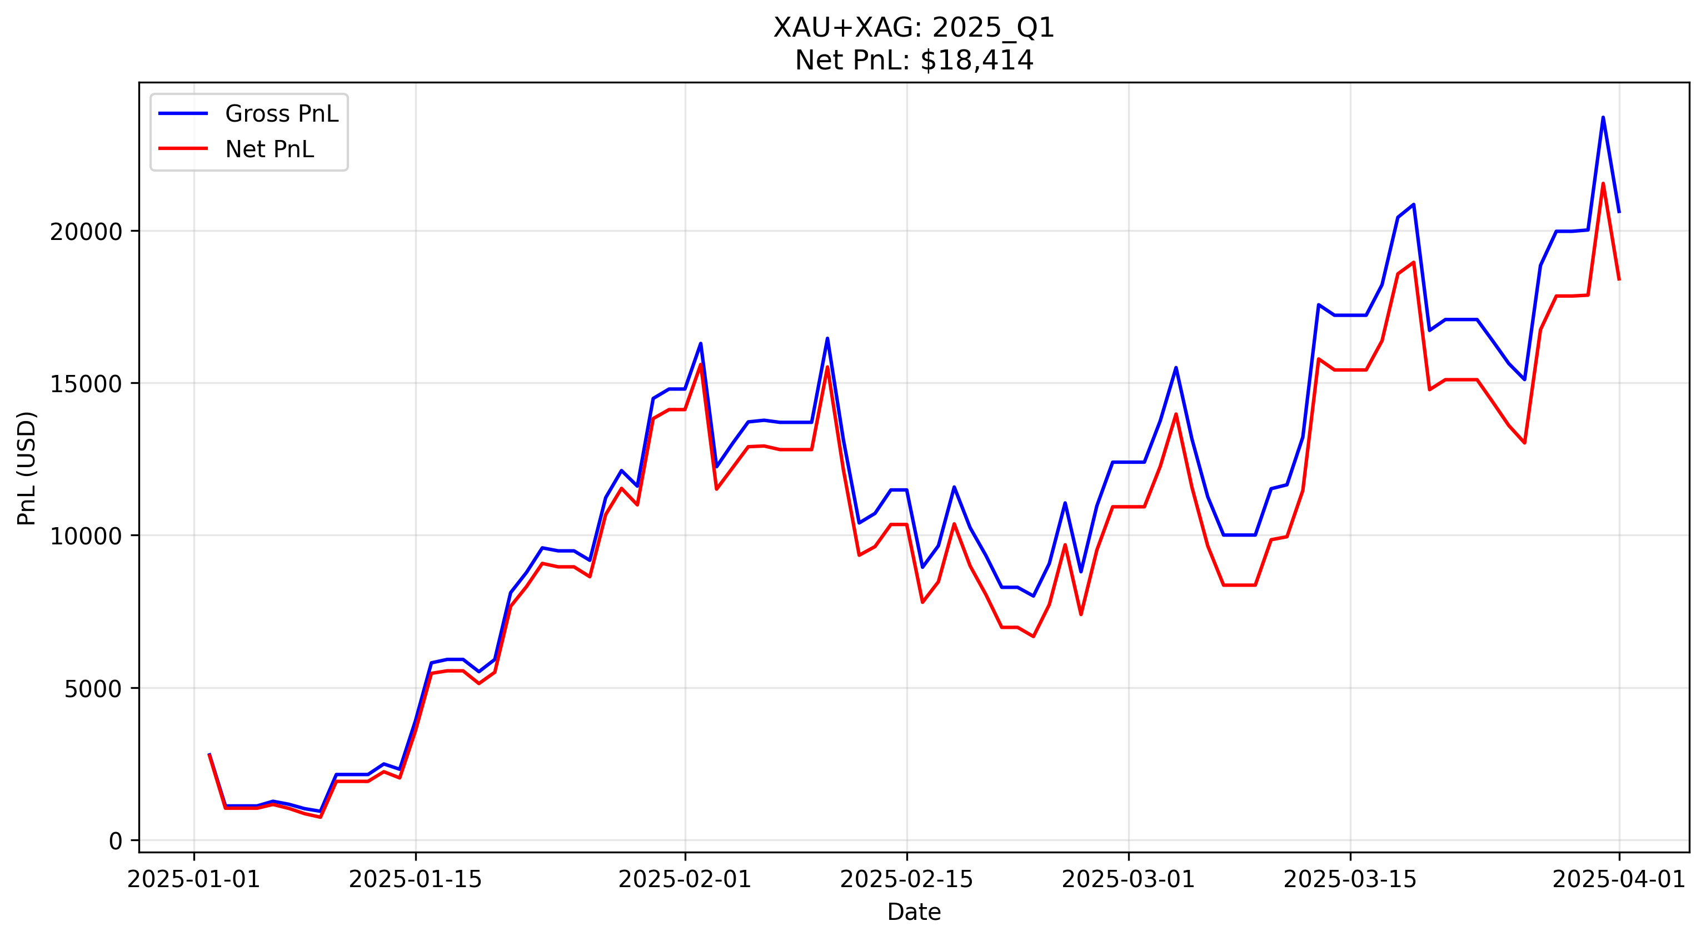

**Comment**: A highly profitable but volatile quarter. After a strong initial trend in January, the strategy experienced a drawdown during a February correction, giving back open profits. However, the system successfully identified the trend resumption in March, recovering all losses and finishing the quarter near equity highs.

### 2025Q2

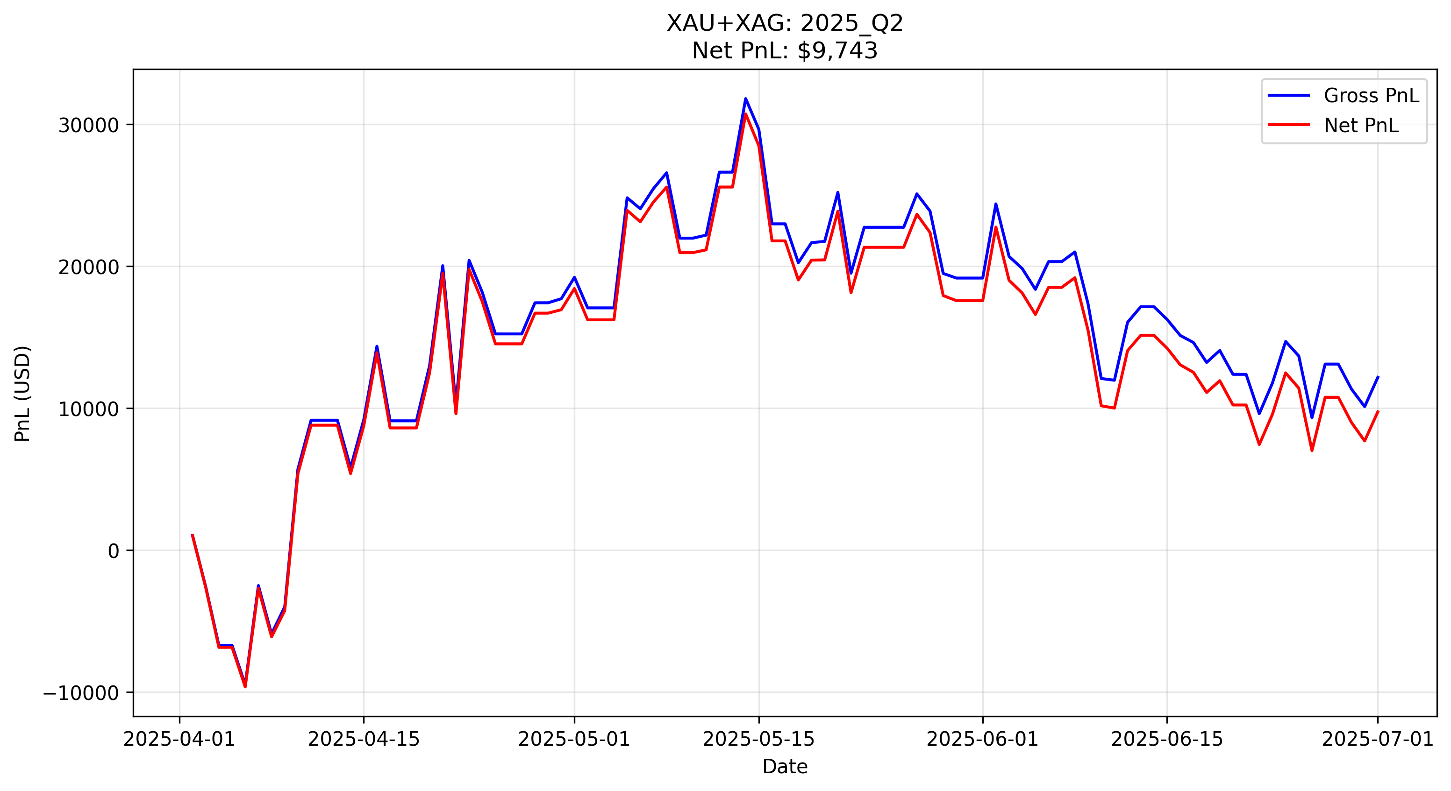

**Comment**: Profitable but volatile. The strategy captured early gains but gave back profits during a late-quarter reversal. The system correctly adhered to stops, preventing a catastrophic reversal, though the Sharpe ratio was impacted by the late volatility.

### 2025Q3 - out of sample

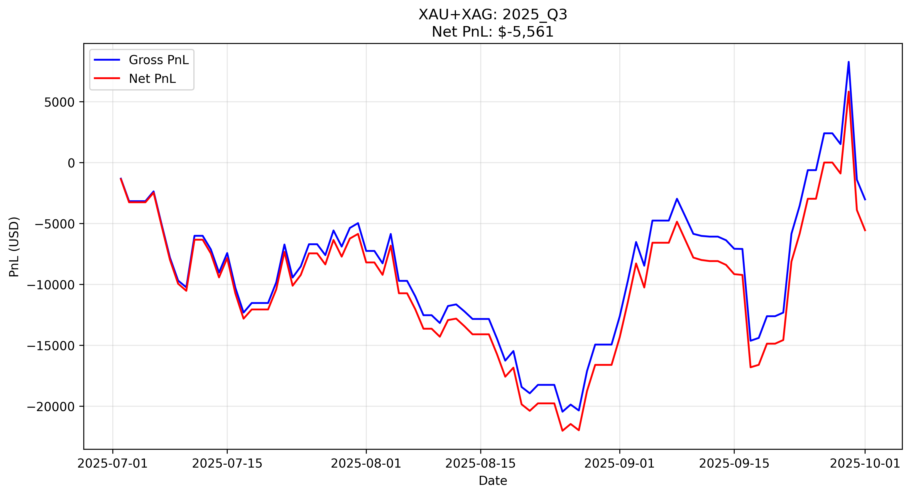

**Comment**: A challenging, volatile period. The equity curve shows significant two-way action, with a deep drawdown in mid-August followed by a sharp recovery in late September. While the quarter ended negative, the late-stage recovery demonstrates the strategy’s ability to react quickly when volatility returns.

### 2025Q4 - out of sample

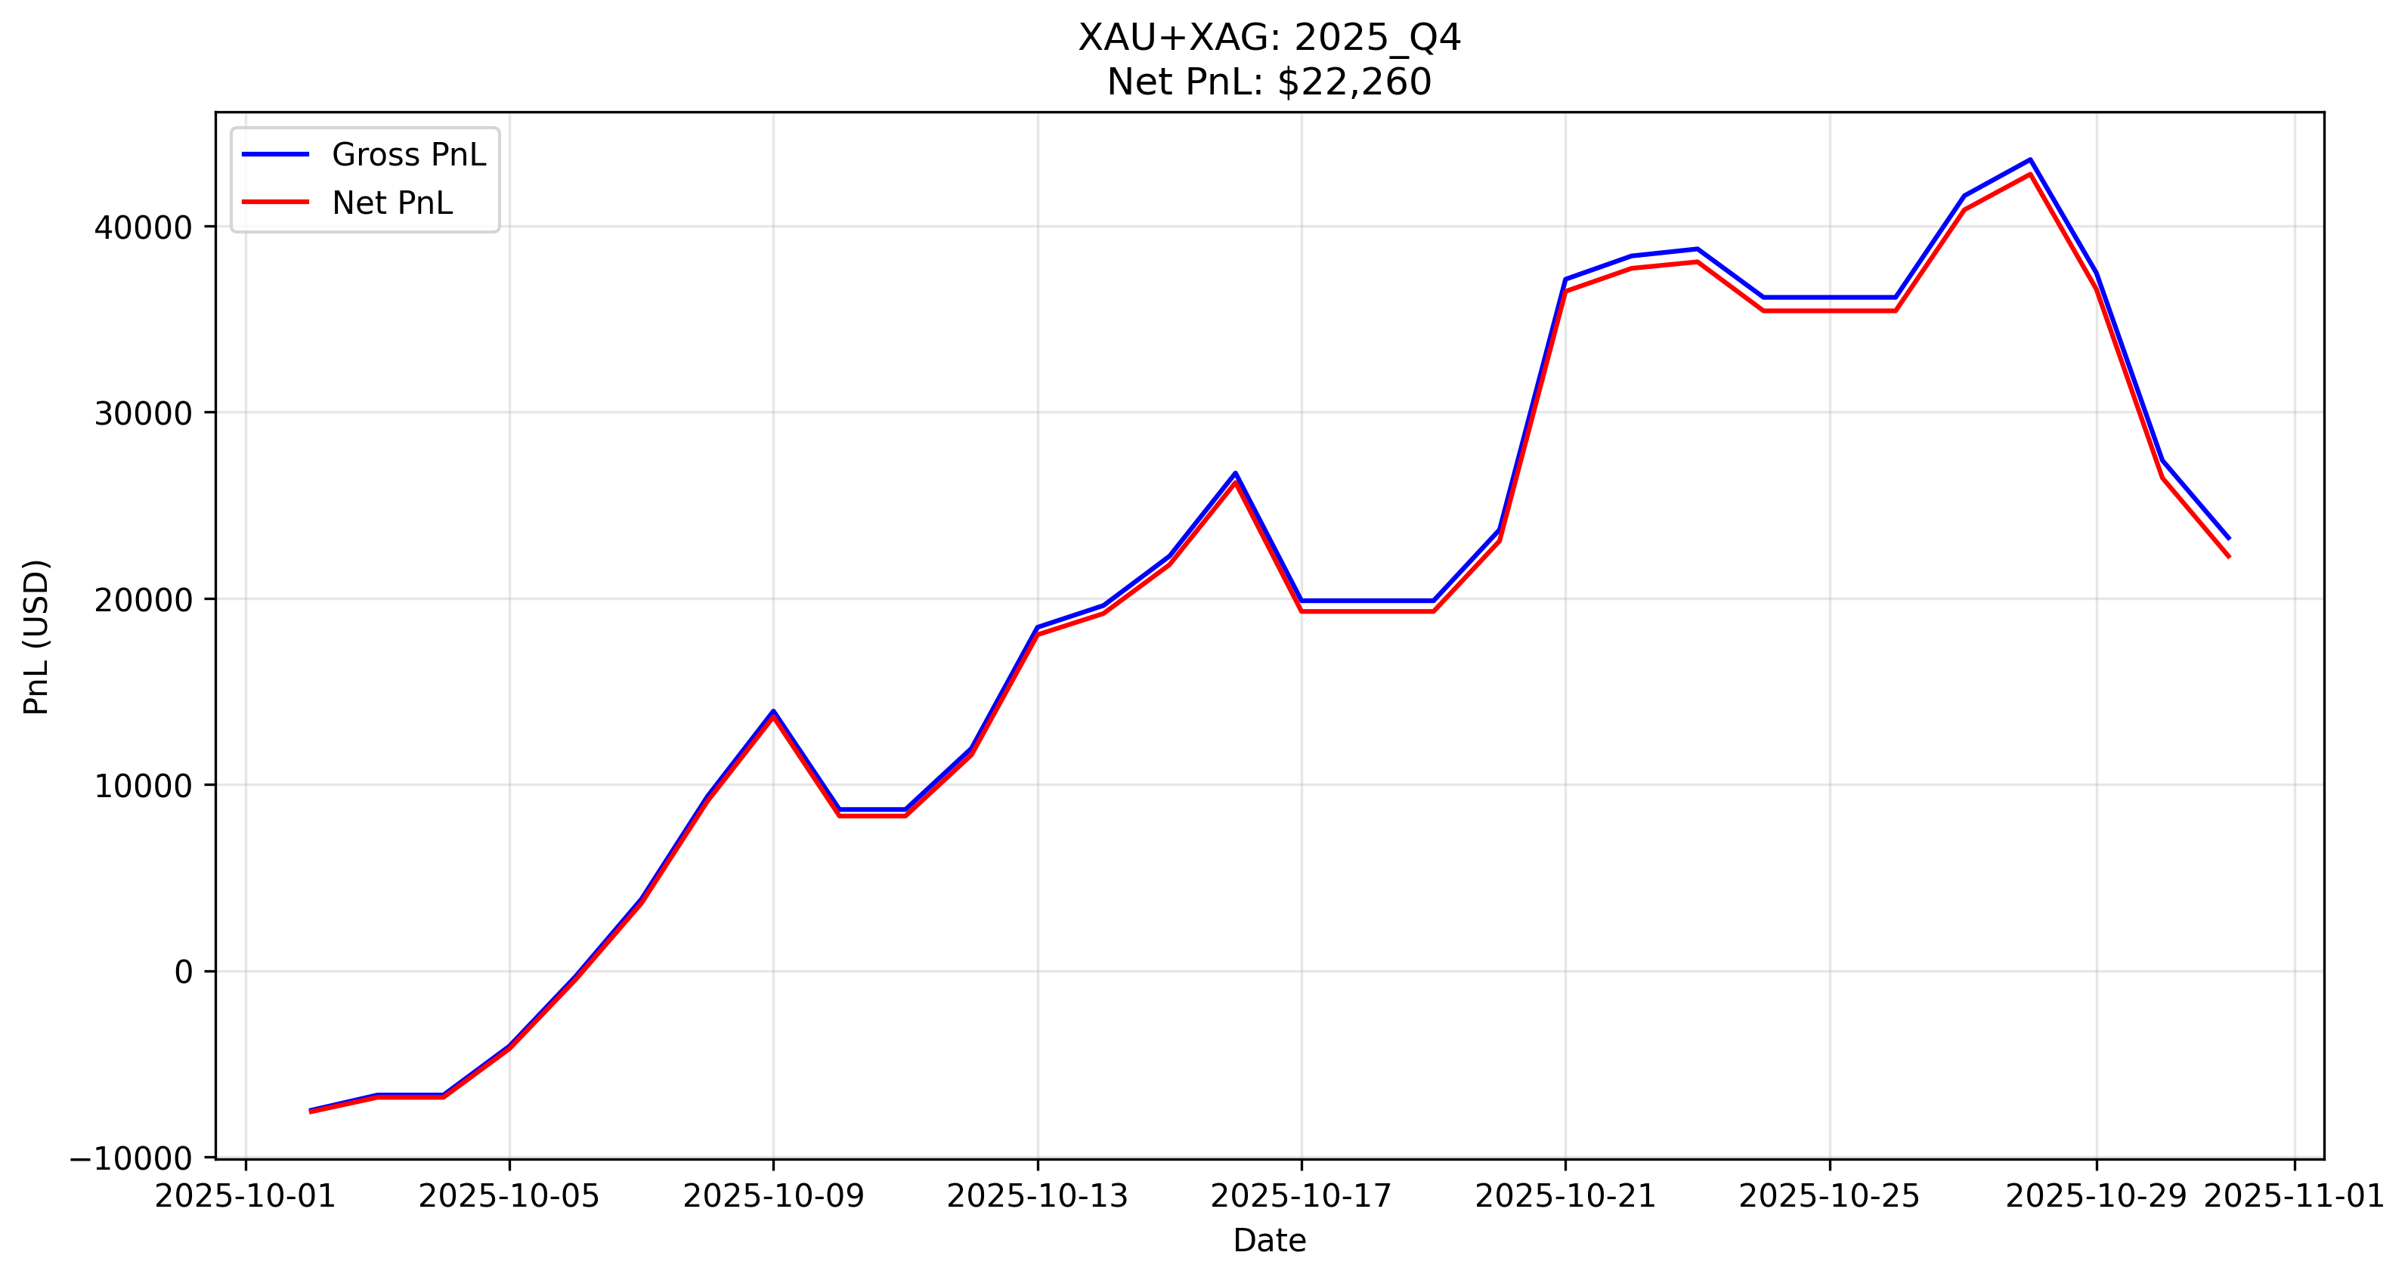

**Comment** This quarter behaved similarly to 2024 Q4, with an immediate and sustained explosive trend. The strategy entered early in October and rode the momentum through the entire month, generating substantial profits ($22k+) with very little drawdown, proving the robustness of the logic in strong bull markets.

# Summary and conclusions

## Group 1

Across the evaluated quarters, the Group 1 strategy demonstrates a clear **regime split**: the NQ momentum breakout performs best when trends persist, while the SP mean‑reversion component performs best when prices oscillate around the slow EMA center. This pairing reduces reliance on a single market condition and produces a more balanced behavior than applying one style universally. However, the gross-to-net differences show that **cost assumptions are a key sensitivity**, especially in lower-edge quarters when turnover remains non-trivial. Overall, we consider the strategy to be **interpretable and economically plausible** on Group 1, provided that risk limits (drawdown control) and realistic execution/cost modeling are enforced.

## Group 2

Our analysis of the metals complex led to the selection of a **Hybrid Volatility Breakout** strategy. The key findings are:

* **Regime Separation:** Gold and Silver require different execution logic. Gold’s global liquidity supports a 24-hour trend-following approach, while Silver’s noise and high point-value risk necessitate a strict “US-Session Only” filter.
* **Cost Management:** With fixed costs of $15 and $10 per trade, standard high-frequency signals fail. Extending lookback windows to 12h–24h was critical to increasing the average trade size enough to overcome the cost hurdle.
* **Portfolio Resilience:** The combined strategy offers a robust profile. Gold provides the offensive capability to capture major trends, while Silver’s time-gating provides defensive diversification, often sitting out during periods of low-quality volatility.